Thesis Alignment & Revision Plan
Chapters 1-6 - From Proposal Voice to As-Built Evaluated Prototype
"An IoT-Enabled System for Real-Time Fuel Monitoring, GPS Tracking, and Anomaly Detection in Trucks Using Non-Parametric Unsupervised Machine Learning"

0. Executive Summary - Why This Document Exists
Chapter 6 has already been rewritten in the as-built, evaluated-prototype voice. Chapters 1-5 still read like the June 2026 proposal: they say the system 'will be' built, 'will be' evaluated, and refer to digital float sensors, GSM-primary communication, and a single-interface dashboard - none of which match what was actually built. This document is the authoritative work-package to align the entire manuscript with the implementation that now lives in the repository.
Core thesis-wide rewrite rule:
Change every paragraph from 'proposed system / will be evaluated / expected deliverables' to 'implemented system / evaluated prototype / measured results.'
Final chapter framing (write this on a sticky note):
Chapter 1 = What problem, why it matters, what was built
Chapter 2 = What existing works lack (now including Barbado & Corcho)
Chapter 3 = Theory behind the methods (now including OBD-II, filtering, LOTO, Wilson CI)
Chapter 4 = Why these design choices were selected (final hardware + ML decisions)
Chapter 5 = How the system was implemented and evaluated (move architecture here)
Chapter 6 = What the measured results were (results only)
Source-of-truth references used throughout this plan:
· Embedded firmware: THESIS/embedded/hmi_phase1/src/main.cpp (9,681 lines)
· Backend API: THESIS/backend/server.js (4,947 lines)
· ML training: THESIS/ml/train_iforest.py, ml/matrix_profile.py, ml/loto_evaluate.py
· DB schema: THESIS/backend/db/schema.sql + supabase/migrations/
· Result artefacts: THESIS/docs/results/{so1_fuel, so2_comm, so3_gps, so4_ml, so5_alerts}/
· Chapter 6 source: THESIS/docs/results/chapter 6/so1..so5_*.md (already in evaluated voice)
· Methodology snippets (already paragraph-form): THESIS/docs/results/methodology_snippets.md
Author assignment grid (suggested):
Chapter | Lead Author (suggested)
Abstract + Ch.1 Introduction | DE LA ROSA
Ch.2 Literature Review | DE LA ROSA
Ch.3 Theoretical Considerations | CASTELO (already wrote ML/theory)
Ch.4 Design Considerations | CASTELO
Ch.5 Methodology (largest delta) | MONTEMAYOR + BARJA
Ch.6 Results (final polish) | BARJA

1. The Repo Truth (read this before editing anything)
Many proposal-era statements are no longer accurate. The list below is what the code actually does as of commit on 2026-06-24. Use it as the factual anchor when rewriting any chapter.

1.1 Fuel acquisition
· Channel: Toyota meter Mode 22 command 0x21 0x29 over OBD-II (main.cpp:7899, 7922) - NOT an externally installed float sensor.
· Polling cadence: 1.5 s per OBD poll (see fuel loop). Telemetry interval to backend: TELEMETRY_INTERVAL_MS = 5000 ms (main.cpp:178).
· Filter cascade in firmware (main.cpp:7743-7775): median-of-31 (FUEL_WIN=31, widened from 15 on 2026-06-23) -> EMA alpha=0.04 (~110 s memory) -> dead-band publisher -> direction-aware step rule (down at >=2.5 % real burn always allowed; up at >=10 % only if stationary >=60 s, otherwise treated as slosh).
· Post-refuel quiescence: 5-minute freeze after refuel anchor (REFUEL_QUIESCENCE_MS = 300000UL).
· Warm-up rule: first 3 samples per trip suppressed; HMI shows 'Loading'.
· Field reference: manufacturer dashboard gauge - dipstick was not legally permitted on the partner Toyota Hilux.

1.2 Vehicle context data from OBD-II
· Captured alongside fuel: engine_rpm, engine_load_pct, throttle_pct, maf_gps, coolant_temp_c, engine_runtime_sec, dtc_present, dtc_count (schema.sql:116-123).
· Speed/odometer: speed (km/h), odometer_km, with three distance deltas (distance_gps_delta_km, distance_obd_delta_km, distance_fused_delta_km).

1.3 Communication stack (final)
· Priority chain (HMI intelligent traffic steering, locked 2026-06-10): LoRa -> LTE -> GSM 2G -> WiFi -> SPIFFS offline buffer.
· LoRa: SX1278 @ 433 MHz, 17 dBm, SF7, BW 125 kHz; bidirectional with gateway active-trip tracker, 5 s / 15 s pollers, HMI continuous listener.
· Cellular: A7670E modem (Air780E was swapped out 2026-06-09; restored to A7670E via splicing from commit 7a4c750f on 2026-06-17). LTE distinguished from GSM 2G via gsmActiveRat flag.
· Offline path: SPIFFS append-only buffer; drain at 1 record/5 s during a trip, 1 record/s between trips; 50-record minimum per SO2-d.
· channel_used column in telemetry_logs is constrained to {'lora','gsm','offline_replay','mobile_app','simulation'} (schema.sql:104).

1.4 Backend, database, and three interfaces
· Backend: Node/Express on Render at https://thesis-ug1z.onrender.com.
· DB: Supabase Postgres. Tables: users, trucks, trip_sessions, telemetry_logs, archived_telemetry_logs, trip_summaries, alerts, latency_logs.
· Active-trip uniqueness enforced by partial unique indexes (uniq_one_active_trip_per_truck and ..._per_driver, schema.sql:253-259) - this kills duplicate-active-trip race conditions.
· Three user-facing interfaces (this MUST replace 'dashboard for managers only' in the proposal scope): (a) embedded in-truck HMI for drivers, (b) mobile driver web app (PWA) for companion GPS and trip-state sync, (c) administrative dashboard for SGSA fleet monitoring.

1.5 Machine learning (final state)
· Production detector: Isolation Forest Model C. Hyperparams: contamination=0.015, n_estimators=300, max_samples=256, max_features=1.0 (train_iforest.py:51-53).
· Threshold: training quantile q995 + IQR margin baked at +0.003 (calibrated 2026-06-23). Model C achieves P=0.966, R=0.966.
· Matrix Profile retained as supporting subsequence detector (window=12, z-threshold=2.0), not the primary production model.
· Validation: leave-one-trip-out (LOTO, see loto_evaluate.py and loto_baselines.py). Public chapter-6 numbers use LOTO partitions.
· ML service: anomaly_service.py Flask microservice; backend invokes via setImmediate after telemetry insert; results written back to telemetry_logs.anomaly_flag/anomaly_score/model_source and an alert row with alert_type='fuel_anomaly' is created.

2. Abstract + Chapter 1 INTRODUCTION

2.1 Abstract - replace proposal-voice phrases
Find/replace these exact strings (current text on lines 24-35 of chap1_5_extract.txt):
Replace this proposal-voice phrase | With this as-built phrase
This study proposes an IoT-based, context-aware system designed to monitor real-time fuel levels, track GPS location, and detect anomalous fuel consumption... | This study developed and evaluated an IoT-based, context-aware fleet monitoring system that acquires real-time fuel level via OBD-II, tracks GPS location, and detects anomalous fuel consumption...
leverages CAN Bus/OBD-II interfacing for ECU fuel data | acquires fuel level through the Toyota meter Mode 22 PID 21/29 channel of the OBD-II interface, with a four-stage filter cascade (median-of-31, EMA, dead-band, direction-aware step rule) implemented on an ESP32-based in-truck HMI
LoRa and GSM modules for reliable IoT-based communication | a prioritised LoRa -> LTE -> GSM -> WiFi -> SPIFFS-offline communication stack that guarantees delivery acraoss urban, highway, and dead-zone segments
The system will be evaluated in real-world driving scenarios to measure detection accuracy, false positive rates, and response latency. | The prototype was evaluated using controlled-environment trip data and live telemetry data to measure detection accuracy, false positive rates, and response latency.
This integrated platform aims to enhance operational safety... | The integrated platform - in-truck HMI, mobile driver web app, and administrative dashboard - was deployed end-to-end and demonstrated to enhance operational safety...

Add one new sentence near the end of the abstract:
Three user-facing interfaces were delivered: an embedded in-truck HMI for drivers, a mobile driver web application for companion GPS and trip-state synchronisation, and an administrative dashboard for SGSA fleet monitoring.

2.2 Chapter 1 - Background (Section 1.1)
Add a sentence in the closing paragraph of the background that flags the non-invasive constraint that drove the OBD-II decision:
Because partner HINO in the Philippines do not permit tank-cap or sender-loom modifications on production trucks, any field-deployable monitoring approach must be non-invasive. This constraint was the dominant driver of the acquisition-layer design adopted in this study.

2.4 Chapter 1 - Scope and Delimitations (Section 1.7)
Replace any mention of a single-interface dashboard with this scope clause:
The system includes three user-facing interfaces: an embedded in-truck HMI for drivers (ESP32 + ILI9341 TFT + capacitive buttons + buzzer), a mobile driver web application for companion GPS and trip-state synchronisation, and an administrative web dashboard for SGSA fleet monitoring, alert management, and trip analytics. Driver, mobile, and dashboard states are reconciled at the backend via the trip_sessions, telemetry_logs, and alerts tables to ensure a single source of truth across interfaces.
Add an explicit delimitation paragraph (this protects you from dipstick-validation criticism):
Direct manual dipstick fuel-volume calibration was not within the delimitations of this study because the partner fleet operator does not authorise tank-cap opening on production trucks during fuel-validation activity, and the project's ethical clearance protocol does not cover the additional consent required for that procedure. Fuel-accuracy validation is therefore based on (a) operational-agreement checks against the manufacturer dashboard gauge and (b) per-tank-level variance characterisation of the filtered signal against the raw OBD-II sender.
Direct manual dipstick fuel-volume calibration was not within the delimitations of this study because the partner fleet operator does not authorize tank-cap opening or fuel-system modifications on production trucks used in normal operations. Consequently, fuel-accuracy validation was based on (a) operational-agreement checks against the manufacturer dashboard gauge and (b) per-tank-level variance characterization of the filtered signal relative to the raw OBD-II sender measurements.

3. Chapter 2 LITERATURE REVIEW

3.1 What you already have
Existing subsections (in chap1_5_extract.txt lines 124-130): 2.1.1 Vehicle Tracking and Fuel Sensing Technologies, 2.1.2 Anomaly Detection, 2.1.3 Machine Learning Applications, 2.2 Lacking in the Approaches, 2.3 Summary. Keep the PRISMA diagram on page 33 - it is good.

3.2 Add Barbado & Corcho as a major related work
Insert this paragraph under section 2.1.3 (Machine Learning Applications). Cite as Barbado, A. and Corcho, O. (2022), 'Interpretable Machine Learning for Anomaly Detection in Fuel Consumption,' Information 13(4), 178.
Barbado and Corcho (2022) developed an explainable machine-learning framework for vehicle fuel-consumption anomalies using real-world telematics data from diesel and petrol fleet vehicles. Their study emphasised that anomaly detection should not only identify abnormal fuel consumption but also explain the operational causes behind the anomaly, using XAI techniques on top of an unsupervised detection layer. They first identified candidate anomalies via a univariate boxplot/IQR outlier method and then trained a contextual model that incorporates domain knowledge such as vehicle subgroup, route type, and driver behaviour. This is directly relevant to the present thesis because fuel anomalies in Philippine logistics must be interpreted with operational context - the same context (driver, route, vehicle, fuel-consumption baseline) is encoded in the Isolation Forest Model C feature set used in Chapter 6.

3.3 Add the boxplot/IQR baseline discussion (this earns the SO4 ablation)
Add the following at the end of section 2.1.2 (Anomaly Detection):
Because published fleet fuel-anomaly work (Barbado and Corcho, 2022) uses boxplot/IQR-based unsupervised detection as an interpretable baseline before applying explainable models, the present study compares Isolation Forest and Matrix Profile against a rule-based / IQR baseline under leave-one-trip-out evaluation. This baseline serves both as a fairness check (to show that the non-parametric models genuinely add value over a thresholding heuristic) and as an ablation reference in Chapter 6.

3.4 Extend the literature gap table
Add this row to the existing 'Lacking in the Approaches' table in section 2.2:
Study | What they did | Limitation | How this thesis responds
Barbado & Corcho (2022) | Used real-world telematics and interpretable ML to detect and explain fleet fuel-consumption anomalies; combined boxplot/IQR pre-filtering with contextual XAI models. | Focused on fleet-level analytics and explanation; did not produce an embedded HMI + OBD-II + multi-channel-communication + live-alert prototype that closes the loop in the vehicle cab. | This thesis integrates OBD-II fuel acquisition (Toyota Mode 22 PID 21/29), embedded HMI, GPS tracking, four-channel communication fallback, backend dashboard, mobile driver web app, and unsupervised anomaly detection (IF Model C + Matrix Profile) in one working prototype evaluated under LOTO.

3.5 What to add to section 2.2 - Lacking in the Approaches
· Add the phrase 'closed-loop in-cab driver feedback' as a missing capability across the surveyed commercial systems (Cartrack, Geotab, Samsara, etc.). Most commercial systems push alerts to the manager dashboard; this thesis pushes alerts to a driver-facing HMI inside the truck cab with rest/snooze acknowledgments captured in the alerts table.
· Add the phrase 'offline-tolerant telemetry with explicit replay accounting' as a missing capability. The thesis tags every telemetry row with channel_used, including 'offline_replay', which lets the backend distinguish live vs replayed data - rare in academic prototypes.
· Add the phrase 'multi-interface state reconciliation' as a missing capability. The thesis uses partial unique indexes to enforce one-active-trip-per-truck/driver across three concurrent client surfaces (HMI, mobile, dashboard).

4. Chapter 3 THEORETICAL CONSIDERATIONS
Chapter 3 currently covers CPS, sensor theory, time-series synchronisation, IoT communication, GPS, Matrix Profile, and Isolation Forest. Three new subsections must be added so Chapter 6's evaluation language is not introduced cold.

4.1 Add 3.2.X - OBD-II and CAN-based Vehicle Data Acquisition
Insert after 3.2.2 (Sensor Theory and Signal Measurement). Cover:
· OBD-II as the standardised diagnostic access layer (ISO 15765-4 / SAE J1979); Mode 01 generic PIDs vs Mode 22 manufacturer-specific PIDs.
· CAN as the physical/data-link transport (ISO 11898-1/2).
· ECU-reported signals available via OBD-II: fuel level, engine RPM, vehicle speed, engine load, throttle position, MAF, coolant temperature, runtime, DTCs.
· Manufacturer-specific access: Toyota Mode 22 PID 21/29 returns the raw fuel-sender voltage encoded at 0.5 L per ADC count without internal damping.
· Why non-invasive acquisition matters in fleet partnerships: warranty, ethical clearance, insurance, retrofittability across vehicle subtypes.
· Limitation: not all PIDs are standardised; the raw sender exhibits slosh-induced and ADC-quantisation bounce of approximately +/-5 L, motivating the filter cascade introduced in 3.2.X (next subsection).

4.2 Add 3.2.X - Signal Filtering for Fuel-Level Stabilisation
Insert immediately after the new OBD-II subsection. Cover the theory of each stage that the firmware then realises:
· Median filtering for spike rejection - order statistic that is robust to burst outliers; window length is a trade-off between latency and rejection.
· Exponential moving average (EMA) for residual smoothing - linear IIR low-pass, settling time approximately 4/alpha samples.
· Dead-band publish logic for display stability - quantises the published value to integer percentage to prevent visible jitter on the HMI gauge.
· Direction-aware step rule for slosh rejection - asymmetric thresholds for downward (real consumption) vs upward (refuel only valid when stationary) transitions, justified by the physics of fuel-tank slosh during motion.
· Warm-up suppression - sub-window-length samples are not yet representative; the published series begins only after the median window is fully populated.

4.3 Add 3.2.X - Evaluation Metric Theory
Insert as the final theoretical subsection before 3.3 Summary. Cover:
· Confusion matrix (TP, FP, TN, FN) for binary classification.
· Precision = TP / (TP + FP); the SO4 target is precision >= 90 %.
· Recall = TP / (TP + FN); the SO4 secondary target is recall >= 85 %.
· False positive rate (FPR) = FP / (FP + TN); the SO4 target is FPR <= 10 %. Important to spell this out because precision alone can be misleading under class imbalance.
· F1 score as the harmonic mean of precision and recall.
· Wilson score confidence interval - preferred over the normal-approximation interval for the small-sample binomial proportions reported in Chapter 6 (fewer than 100 positives per trip).
· Leave-one-trip-out (LOTO) cross-validation - a held-out evaluation protocol where each trip serves once as the test set while the model is trained on the remaining trips; protects against information leakage from within-trip temporal correlations.

5. Chapter 4 DESIGN CONSIDERATIONS
Chapter 4 must translate Chapter 3's theory into the engineering decisions that Chapter 5 then implements. Replace the existing alternative-design discussion with the final design-decision table below.

5.1 Final Hardware and Subsystem Decision Table
Subsystem | Final choice | Alternative considered | Reason for final choice | Known limitation
Fuel acquisition | OBD-II Toyota Mode 22 PID 21/29 | External capacitive / float tank sensor | Non-invasive, no tank modification, ethically clearable, partner-acceptable | Manufacturer dashboard gauge used as field reference (no dipstick validation)
Controller | ESP32 (dual-core, 240 MHz, WiFi+BT) | Arduino Uno / Raspberry Pi | Adequate GPIO + WiFi + dual core for IDF VSPI separation; PlatformIO ecosystem; FreeRTOS scheduling | Limited RAM for on-device ML; ML inference moved to backend
HMI display | ILI9341 2.4" TFT + XPT2046 touch + dedicated buttons | OLED + scroll button only | Full route / fuel / alert UI in-cab; suitable readability in daylight | Touch only used for non-critical actions; physical buttons used for safety-critical confirm
GPS | Embedded GPS (Neo-style) + mobile-app GPS fallback fused at backend | Dashboard-only / external assist only | Resilient to embedded-GPS cold start or building occlusion; tagged via gps_source column | Urban-canyon drift; cold start of embedded module on first power-on
Wide-area comms - primary | LTE via A7670E modem | GSM-only baseline | Higher throughput, lower per-packet latency once attached | HTTPACTION + TLS renegotiation can push median latency to ~23-24 s on certain Smart cells
Wide-area comms - fallback | GSM 2G via same A7670E (with CGNAPN/CFUN+CSTT fallback) | LTE-only | Retained for legacy 2G-only coverage on some Batangas / Tagaytay routes | Lower throughput; not all carriers maintain 2G
Local-area / depot comms | LoRa SX1278 @ 433 MHz, SF7, BW 125 kHz, 17 dBm | WiFi-only at depot | Long range, low power, bidirectional fleet-yard polling without LTE cost | Low duty-cycle limits payload size; 125 kHz BW shared with other depot nodes
Hotspot fallback | WiFi (driver phone tether or depot AP) | no fallback | Recovers comms when LTE+GSM+LoRa are all down but a personal hotspot is available | Depends on driver compliance to enable hotspot
Offline buffer | SPIFFS append-only ring buffer, replayed with channel_used='offline_replay' | RAM-only buffer | Survives reboot; preserves seq + event_id for backend deduplication | Flash wear if drain is starved for very long periods
Backend | Node/Express on Render + Supabase Postgres | Self-hosted Postgres on a VPS | Managed DB, row-level security, free-tier acceptable for thesis-scale traffic | Render cold-start adds latency to the first POST after idleness
ML detector | Isolation Forest Model C (contamination=0.015, n_estimators=300, max_samples=256) | Threshold-only / IQR baseline; Hybrid Union; Hybrid Intersection | Only Isolation Forest variant that met >=90 % precision AND <=10 % FPR under LOTO | Recall depends on injection realism; will be retrained as live anomaly corpus grows
Subsequence detector | Matrix Profile (window=12, z-thresh=2.0) | Drop entirely | Useful confirmatory layer for slow-leak / steady-siphon patterns that single-point IF misses | Less robust than Model C at row-level scoring; retained as supporting evidence only

5.2 Revise the existing CAN/OBD-II paragraph in Chapter 4
Replace the proposal-era CAN/OBD-II sentence in section 4.2.1 with:
The CAN/OBD-II interface was selected as the acquisition layer for fuel level and contextual vehicle data because it satisfies the non-invasive installation constraint imposed by the partner fleet operator. From this single port the prototype acquires speed (km/h), engine RPM, engine load (%), throttle position (%), MAF, coolant temperature, engine runtime, DTC status, and the Toyota meter Mode 22 PID 21/29 fuel-sender voltage encoded at 0.5 L per ADC count. Mode 22 access is manufacturer-specific and was validated on the partner Toyota Hilux; portability to other manufacturers is discussed in the limitations section of Chapter 6.

5.3 Revise the ML design-considerations paragraph in Chapter 4
Isolation Forest was selected as the production detector because Model C (contamination = 0.015, n_estimators = 300, max_samples = 256, score threshold = training-set quantile q995 + IQR margin + 0.003) was the only Isolation Forest configuration that satisfied both the >=90 % precision and >=10 % false-positive-rate targets under leave-one-trip-out evaluation (precision = 0.966, recall = 0.966 - see Chapter 6 Section 4). Matrix Profile (window = 12, z-threshold = 2.0) was retained as a supporting subsequence detector for slow-leak and siphon patterns that single-point Isolation Forest scoring is less sensitive to.

5.4 Add the communication-design justification paragraph
LTE was treated as the primary wide-area data path because it offers the lowest steady-state latency and the highest payload throughput among the available wide-area options. LoRa was retained as a depot/yard and long-range telemetry fallback because of its multi-kilometre range at very low power, demonstrated to >=5 km under open line-of-sight from the Tagaytay ridge to a downhill receiver. GSM 2G was retained as a deeper-fallback for 2G-only coverage pockets on the Batangas and Subic routes. WiFi was retained as a depot / driver-tether path. SPIFFS offline-buffer replay was retained as the final fallback to guarantee no telemetry record is silently lost when all four real-time channels are unavailable.

Chapter 5 - ready-to-paste

5.1 System Architecture and Conceptual Design
The system architecture is an edge-to-cloud fleet-monitoring pipeline in which the embedded HMI performs data acquisition, filtering, trip-state handling, local driver display, and prioritised transmission. The backend stores telemetry, synchronises state across three concurrent client surfaces - the in-truck HMI, the mobile driver web application, and the administrative dashboard - and dispatches anomaly and safety alerts through the same database tables that the three surfaces subscribe to.
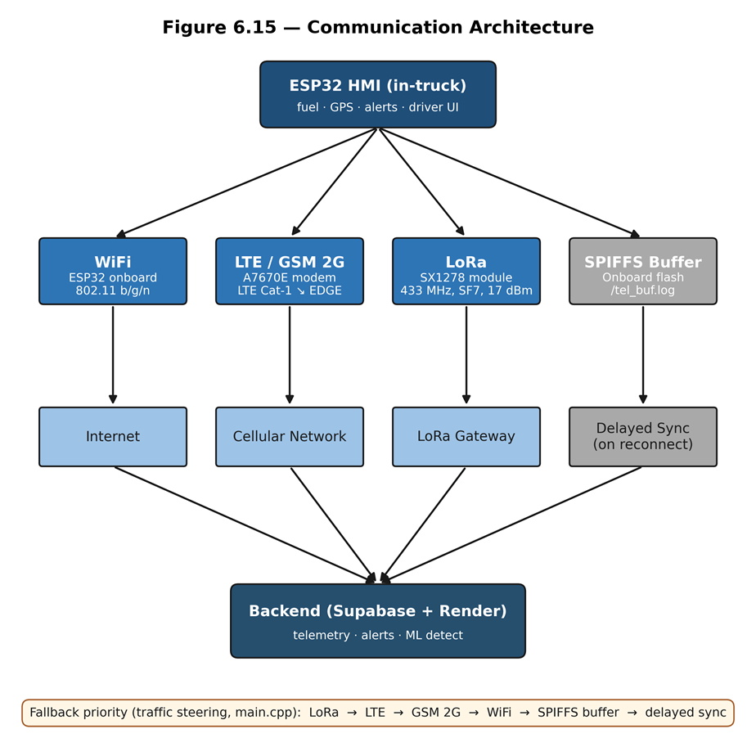
Figure 5.1 - End-to-end Communication architecture
Figure 5.1 illustrates the end-to-end communication architecture of the system, depicting how data flows from the ESP32 HMI through multiple transmission channels to the cloud backend and connected client interfaces. The HMI, serving as edge node, is responsible for collecting fuel, location (GPS), and alert data while also providing the user interface for the driver. From the HMI, data is transmitted through one of three active communication channels — WiFi (802.11 b/g/n), LTE/GSM 2G (LTE Cat-1 to EDGE), and LoRa (433 MHz, SF7, 17 dBm) — each routing through their respective network mediums of Internet, Cellular Network, and LoRa Gateway before converging at the Backend (Supabase + Render), which handles telemetry ingestion, alert dispatching, and ML anomaly detection. While the SPIFFS onboard flash buffer, which serves as the fourth passive channel, operates as a local fallback wherein the stored telemetry can be synced when a connection is re-established. The fallback priority order (LoRa → LTE → GSM 2G → WiFi → SPIFFS buffer → delayed sync) ensures continuous data delivery even under degraded network conditions. From the backend, processed data is simultaneously propagated to the mobile driver web application, the administrative dashboard, and the HMI poll-back, maintaining real-time synchronization across all three client surfaces.
Section 5.1 - data-flow walkthrough:
Truck ECU (OBD-II Mode 22 PID 21/29 fuel + Mode 01 speed/RPM/load/...)
v
ESP32 HMI (main.cpp)
- filter cascade (median-31 -> EMA -> dead-band -> direction-aware)
- trip state machine (Loading / Active / Paused / Ended)
- GPS / OBD distance fusion (distance_*_delta_km columns)
v
Comm steering: LoRa -> LTE -> GSM -> WiFi -> SPIFFS
v
Backend /telemetry POST (server.js)
- telemetry_logs INSERT
- setImmediate -> ML /detect
- contextual gate -> alerts INSERT
v
Supabase Postgres -> Dashboard + Mobile PWA + HMI poll-back

Section 5.1 - End-to-End Telemetry Data Flow
START
WHILE system is running DO
READ ECU fuel data
READ ECU operational data
READ GPS data
APPLY Median Filter
APPLY EMA Filter
APPLY Dead-Band Filter
APPLY Direction-Aware Filter
// UPDATE trip state
IF vehicle is loading THEN
trip_state = "Loading"
ELSE IF vehicle is moving THEN
trip_state = "Active"
ELSE IF temporary stop detected THEN
trip_state = "Paused"
ELSE IF trip completed THEN
trip_state = "Ended"
END IF
COMPUTE fused distance using GPS and OBD data
// SELECT available communication channel
IF LoRa available THEN
Send via LoRa
ELSE IF LTE available THEN
Send via LTE
ELSE IF GSM available THEN
Send via GSM
ELSE IF WiFi available THEN
Send via WiFi
ELSE
Save data to SPIFFS
END IF
SEND telemetry to backend
INSERT telemetry into telemetry_logs
RUN ML anomaly detection
IF anomaly passes contextual gate THEN
INSERT alert into alerts
END IF
UPDATE database
UPDATE dashboard, mobile app, and HMI display
END WHILE
END

5.2 Hardware Methodology
Section 5.2.1 - GPIO map:
Table 5.2.1 - HMI GPIO Map
Pin | Function
GPIO 22 | BTN_TAKE_REST (active-low, debounced 50 ms)
GPIO 39 | BTN_SNOOZE (active-low, debounced 50 ms)
GPIO 25 | Buzzer (PWM through the LEDC peripheral)
GPIO 5 | A7670E modem PWRKEY
Source: embedded/hmi_phase1/src/main.cpp:62-64.
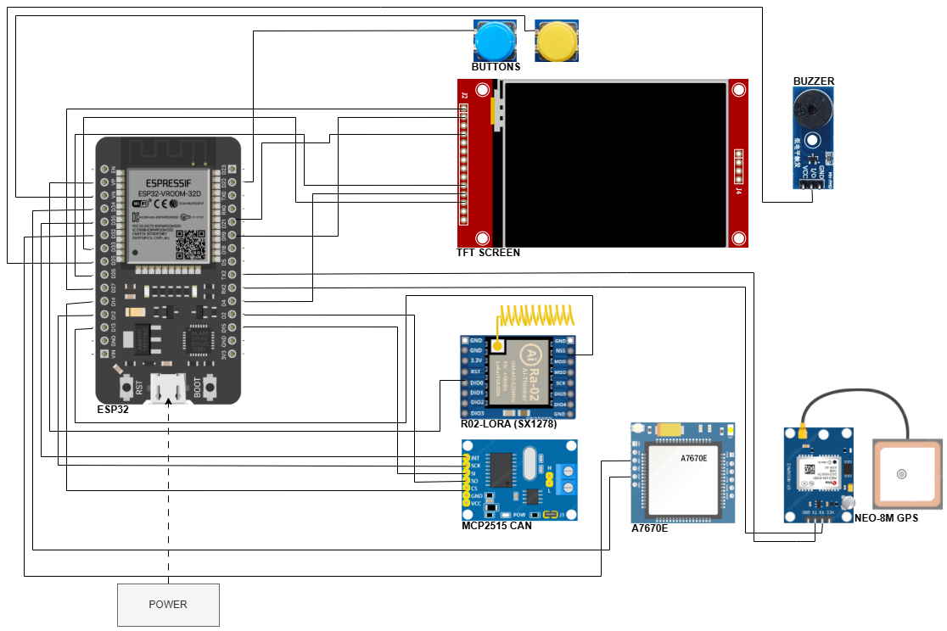
Figure 5.2 ESP32 Hardware Block Diagram

5.3 OBD-II / ECU Fuel and Vehicle Data Acquisition Methodology
Fuel level was acquired through the Toyota meter Mode 22 PID 21/29 channel of the OBD-II interface. The same telemetry cycle also captured contextual OBD-II variables such as speed, engine RPM, engine load, throttle position, mass air flow, coolant temperature, engine runtime, and diagnostic-trouble-code status. These fields were timestamped at the device and transmitted to the backend together with GPS, trip-state, and communication-channel metadata so that the anomaly detector could interpret fuel changes in relation to vehicle operation rather than fuel percentage alone.
Section 5.3 - required structure:
· 5.3.1 Physical interface - OBD-II port, ISO 15765-4 transport.
· 5.3.2 Toyota meter Mode 22 PID 21/29 fuel acquisition (0.5 L per ADC count, 1.5 s polling cadence, NACK retry policy).
· 5.3.3 Co-acquired Mode 01 PIDs - mapping to telemetry_logs columns:
Table 5.3.1 - OBD-II PID to telemetry_logs column mapping
PID | Quantity | Telemetry column
Mode 22 0x21 0x29 | Fuel sender voltage (0.5 L per ADC count) | fuel_level (filtered) + fuel_source='mode22' + fuel_confidence
Mode 01 0x0C | Engine RPM | engine_rpm
Mode 01 0x0D | Vehicle speed (km/h) | speed
Mode 01 0x04 | Calculated engine load (%) | engine_load_pct
Mode 01 0x11 | Throttle position (%) | throttle_pct
Mode 01 0x10 | Mass air flow (g/s) | maf_gps
Mode 01 0x05 | Engine coolant temperature (degC) | coolant_temp_c
Mode 01 0x1F | Time since engine start (s) | engine_runtime_sec
Mode 03 / 0x01 | Stored DTCs (count + presence) | dtc_present, dtc_count

· 5.3.4 Validity / confidence fields (fuel_valid, fuel_source, fuel_confidence) - all written every telemetry cycle.
· 5.3.5 Timestamping (device-side original_device_timestamp vs backend-side timestamp; server_now reconciliation).
· 5.3.6 Field-reference choice (manufacturer dashboard gauge - justified in Ch.1 delimitations because dipstick not permitted).

5.4 Fuel Preprocessing Methodology
The raw OBD-II fuel reading was passed through a multi-stage edge filter before publication. A median window rejects single-sample spikes caused by slosh and sender chatter; an exponential moving average smooths residual noise; a dead-band publisher prevents display jitter; and a direction-aware step rule permits downward movement consistent with fuel burn while rejecting upward movement during motion unless a stationary refuel signature is observed. This filtered value is the fuel percentage displayed on the HMI and stored in telemetry_logs.

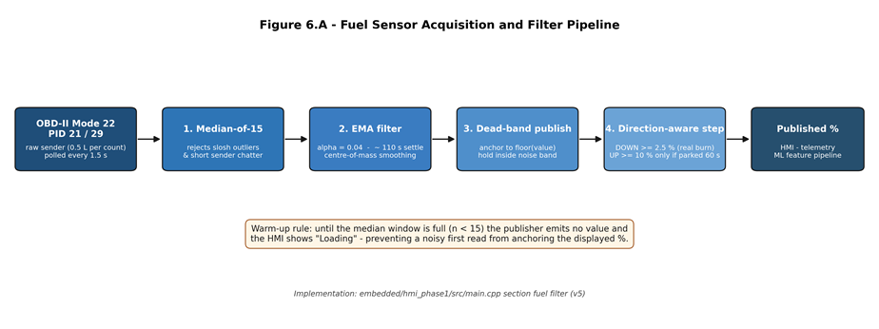
Figure 5.4 - Fuel-level filter cascade. The raw OBD-II Mode 22 PID 21/29 fuel sample (every 1.5 s) is passed through a five-stage cascade: median-of-31 -> EMA (alpha = 0.04) -> dead-band publisher -> direction-aware step rule -> post-refuel quiescence freeze. The published percentage feeds the HMI display and the telemetry stream.
Section 5.4 - cascade specification:
Raw OBD-II Toyota Mode 22 PID 21/29 fuel value (every 1.5 s)
Stage 1: Median over 31 most-recent samples (~45 s memory)
Stage 2: EMA alpha = 0.04 (~110 s settling)
Stage 3: Dead-band publisher (anchor displayed % to floor(EMA))
Stage 4: Direction-aware step rule
DOWN allowed if EMA falls >= 2.5 % below anchor (real burn)
UP allowed only if EMA rises >= 10 % above anchor
AND vehicle stationary >= 60 s (refuel signature)
Stage 5: Post-refuel quiescence freeze for 5 min (REFUEL_QUIESCENCE_MS)
Published fuel % -> HMI display + telemetry_logs.fuel_level
Section 5.4 - warm-up rule:
The first three samples per trip session are withheld from publication and the human-machine interface displays the placeholder 'Loading' until the median window has been populated, preventing a noisy first read from anchoring the displayed value at an inaccurate level.

5.5 Communication and Offline Sync Methodology
Section 5.5 - required sub-structure:
· 5.5.1 Priority chain rationale
· 5.5.2 Module comparison table (Table 5.5.1, below)
· 5.5.3 Method radar (Figure 5.5.1, below)
· 5.5.4 Telemetry JSON schema (below)
· 5.5.5 Buffer fall-through flowchart (Figure 5.5.2, below)
· 5.5.6 Fall-through policy paragraph (below)
· 5.5.7 Security (per-packet HMAC, HTTPS / TLS)
· 5.5.8 LoRa range protocol
· 5.5.9 GSM/LTE drive-test protocol
· 5.5.10 Packet-delivery and buffering protocol
Section 5.5.1 - priority chain rationale:
LTE was treated as the primary wide-area data path because it offers the lowest steady-state latency and highest payload throughput among the available wide-area options. LoRa was retained as the depot/yard and long-range telemetry path because of its multi-kilometre line-of-sight reach at very low power. GSM 2G was retained as the deeper-fallback for 2G-only coverage pockets on the Batangas and Subic routes. WiFi was retained as a depot or driver-tether path. SPIFFS offline-buffer replay is the final fallback that guarantees no telemetry record is silently lost when all four real-time channels are unavailable.
Section 5.5.2 - Table 5.5.1:
Table 5.5.1 - Communication Module Comparison
Module | Technology | Hardware | Bandwidth | Range | Power | Role
WiFi | 802.11 b/g/n | ESP32 built-in | ~10 Mbps | ~50 m | Low | Depot and driver hotspot
LTE | LTE Cat-1 | A7670E | ~10 Mbps | Cell coverage | Medium | Primary cellular path
GSM 2G | EDGE | A7670E fallback | ~80 kbps | Wider than LTE | Medium | Cellular fallback
LoRa | SX1278, 433 MHz, SF7, BW 125 kHz | RA-02, 17 dBm TX | ~5.5 kbps | ~50 m urban NLOS @ 97 % (measured); ~1 km open LOS @ 60 % (measured); up to 10 km LOS per SX1278 datasheet | Very low | Primary telemetry path (intelligent traffic-steering chain)
Offline | - | SPIFFS flash | - | - | None | Outage replay

Sources: main.cpp:78-102 (LoRa parameters), main.cpp:47-52 (modem UART). The LoRa range column is reported as two values - the operational urban NLOS reach measured in this study and the line-of-sight reach published in the SX1278 datasheet. LoRa is the highest-priority transport in the intelligent-traffic-steering chain (LoRa -> LTE -> GSM 2G -> WiFi -> SPIFFS buffer); the cellular path provides coverage of the urban-NLOS regime past ~50 m where LoRa delivery degrades.
Section 5.5.3 - Figure 5.5.1:
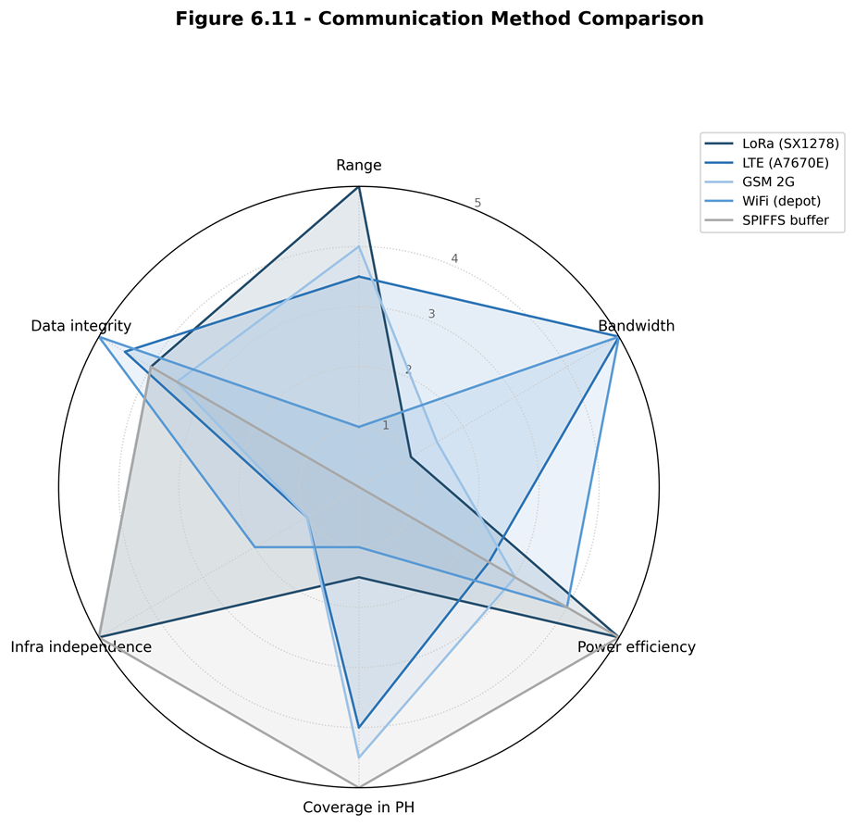
Figure 5.5.1 - Communication Method Comparison radar. Five channels (LoRa / LTE / GSM 2G / WiFi / SPIFFS) compared on six axes - range, bandwidth, power efficiency, Philippine coverage, infrastructure independence, data integrity - normalised to a five-point scale.
Section 5.5.4 - telemetry JSON schema:
{
"truck_id": "<uuid>",
"driver_id": "<uuid>",
"trip_id": "<uuid>",
"sent_at": "<iso-8601>",
"original_device_timestamp": "<iso-8601>",
"source_device": "hmi" | "mobile",
"fuel_level": <0..100>, "fuel_valid": <bool>,
"fuel_source": "...", "fuel_confidence": <0..1>,
"lat": <float>, "lon": <float>,
"gps_source": "embedded_gps" | "mobile_gps" | "fused_mobile_fallback",
"gps_accuracy_m": <float>, "gps_heading_deg": <float>,
"mobile_speed_mps": <float>,
"speed": <km/h>, "odometer_km": <float>,
"engine_status": "on" | "off" | "idle",
"seq": <bigint>, "event_id": "<uuid>",
"channel_used": "lora"|"gsm"|"offline_replay"|"mobile_app"|"simulation",
"comm_channel": "...",
"hmi_driving_sec": <int>, "hmi_rest_sec": <int>, "hmi_trip_status": "...",
"engine_rpm": <int>, "engine_load_pct": <float>, "throttle_pct": <float>,
"maf_gps": <float>, "coolant_temp_c": <float>, "engine_runtime_sec": <int>,
"dtc_present": <bool>, "dtc_count": <int>,
"distance_gps_delta_km": <float>, "distance_obd_delta_km": <float>,
"distance_fused_delta_km": <float>
}
Section 5.5.5 - Figure 5.5.2:
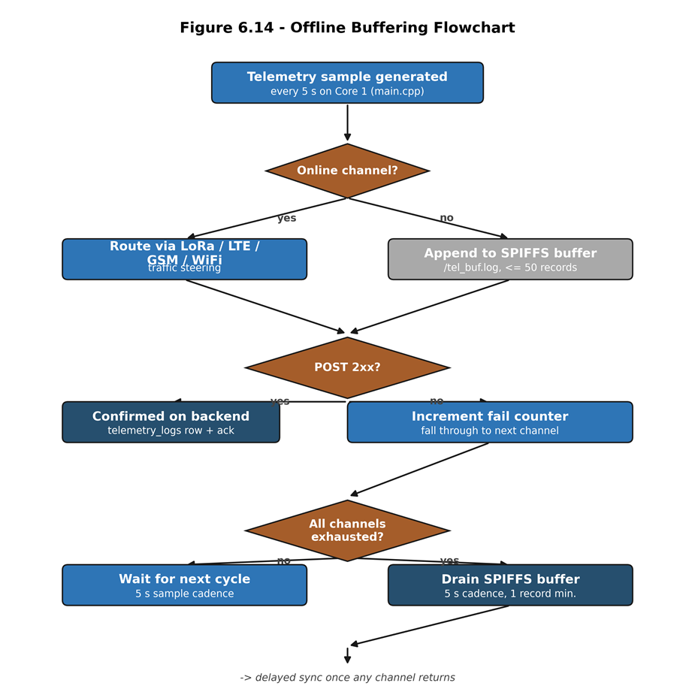
Figure 5.5.2 - Offline-buffer fall-through flowchart. The decision tree executed by the Core 0 worker each five-second sample cycle: a telemetry sample is first routed through the highest-priority online channel; on a non-2xx response the worker falls through to the next channel and, if all channels are exhausted, appends the record to /tel_buf.log. The buffer drains on a five-second cadence with a guaranteed-forward-progress minimum of one record per worker pass.
Section 5.5.6 - fall-through policy:
Each telemetry record is attempted on the highest-priority available channel - LoRa first if a gateway uplink is in range, otherwise LTE, then GSM 2G, then WiFi. If an attempt fails (non-2xx response from the backend or modem error), the firmware falls through to the next channel without duplicating the seq or event_id. If all real-time channels fail, the record is appended to the SPIFFS ring buffer and replayed once any channel recovers; the replayed record is tagged channel_used = 'offline_replay' so the backend can distinguish live from replayed data. HMAC signing of the payload and HTTPS / TLS transport protect the telemetry against tampering and eavesdropping on the cellular path.
Section 5.5.8/9/10 - protocols (paste verbatim from methodology_snippets.md):
5.5.8 LoRa range test protocol. The LoRa physical-layer range test was conducted with the SX1278 module configured at seventeen-dBm transmit power, four-hundred-thirty-three-megahertz centre frequency, spreading factor seven, and one-hundred-twenty-five-kilohertz bandwidth. One hundred telemetry-sized packets were transmitted from the in-truck node to a fixed gateway at each of the open line-of-sight distances of ten, fifty, one hundred, two hundred and fifty, five hundred, one thousand, two thousand, and five thousand metres, and at the urban non-line-of-sight distances of one hundred, two hundred and fifty, and five hundred metres. The received-signal-strength indicator, the signal-to-noise ratio, and the successfully-received-packet count were recorded at the gateway for each distance band.
5.5.9 GSM / LTE drive-test protocol. Carrier-reported signal quality was logged via the AT+CSQ command issued to the A7670E modem at five locations of operational interest: the depot, a Metro Manila urban environment, a highway corridor, a tunnel or underpass selected to trigger the buffer-activation path, and a provincial route in Batangas exhibiting two-gigahertz-only coverage. The per-packet upload latency was computed at the backend as the difference between the device-side sent_at timestamp and the backend-side receipt timestamp; the fiftieth- and ninety-fifth-percentile latencies are reported per location alongside the successful-upload fraction.
5.5.10 Packet-delivery and buffering protocol. A drive route was executed that traversed three distinct connectivity regions: an urban region with strong LTE coverage, a highway region with marginal LTE coverage, and a confirmed no-signal dead zone. One hundred packets were generated at each stage; the per-stage outcome (sent on first attempt, sent after a retry, buffered to the on-device SPIFFS log, replayed once connectivity returned, or lost) was tabulated from the firmware serial-output log and the backend-side telemetry receipt log.

5.6 Backend and Database Methodology
Section 5.6 - required sub-structure:
· 5.6.1 Backend stack (Node/Express on Render + Supabase Postgres).
· 5.6.2 Schema table (below).
· 5.6.3 ERD diagram (to be produced).
· 5.6.4 Cross-interface trip-sync flow (below).
· 5.6.5 Active-trip uniqueness enforcement.
· 5.6.6 Odometer and trip-distance methodology (absorbed §6.2.9).
· 5.6.7 Alert rule engine (Tables 5.6.2 and 5.6.3 below).
· 5.6.8 Archival pipeline.
Section 5.6.2 - Table 5.6.1 (DB schema):
Table 5.6.1 - Supabase Postgres schema (from backend/db/schema.sql)
Table | Purpose | Key columns
users | Accounts (head_admin / fleet_manager / manager / driver) | id, role, assigned_truck_id
trucks | Vehicle profile + maintenance state | id, truck_code, plate_number, current_odometer_km, status
trip_sessions | Active / paused / ended trips with destination, route polyline, nav state, mobile-GPS columns | id, truck_id, driver_id, trip_status, distance_km, assigned_destination, route_steps, mobile_lat/lon
telemetry_logs | Per-cycle fuel + GPS + OBD context + anomaly flag | fuel_level, lat/lon, speed, odometer_km, channel_used, anomaly_flag, anomaly_score, model_source
archived_telemetry_logs | Older trip telemetry beyond retention window | same as telemetry_logs + archived_at + archive_reason
trip_summaries | Per-trip aggregates upserted by refresh_trip_summary() RPC | total_distance_km, total_alerts, total_anomalies, average_fuel_level
alerts | Rest / maintenance / overspeed / low_fuel / fuel_anomaly events | alert_type, severity, is_resolved, trip_id
latency_logs | SO2-c latency tracking (sent_at vs received_at) | latency_ms, channel_used, retry, sent_at, received_at

Section 5.6.3 ERD diagram
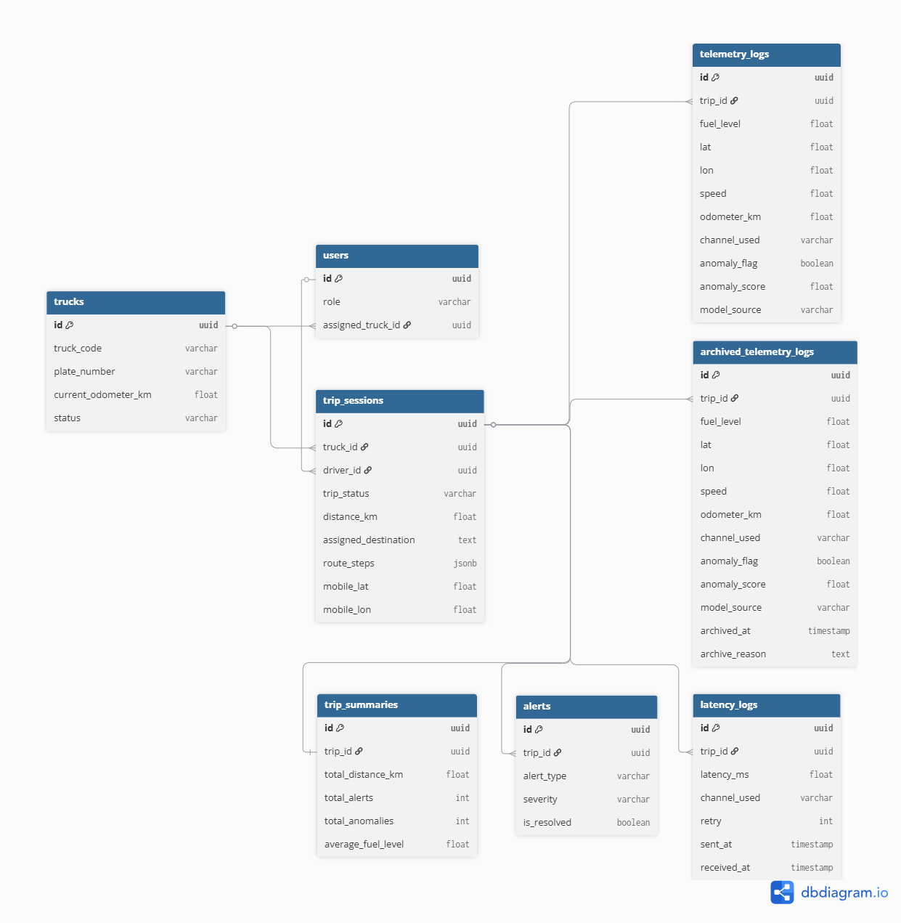
Figure 5.6 ERD Diagram
Figure 5.6 presents the Entity-Relationship Diagram (ERD) of the system's Supabase PostgreSQL database, containing eight interrelated tables: trucks, users, trip_sessions, telemetry_logs, archived_telemetry_logs, trip_summaries, alerts, and latency_logs. The trip_sessions table serves as the main hub for the relationships among these tables, linking trucks (truck_id) and drivers (driver_id). The other tables such as telemetry_logs, archived_telemetry_logs, trip_summaries, alerts and latency_logs, reference the trip by trip_id in order to relate records in the respective tables to a specific trip session. This data structure is designed to maintain referential integrity throughout the schema and support scalable access to the HMI dashboard, mobile app, and backend analytic pipeline.
Section 5.6.4 - cross-interface sync flow:
Driver presses Start Trip on HMI (or mobile app)
v
Backend POST /trip/start -> trip_sessions INSERT (trip_status='active')
uniq_one_active_trip_per_truck and ..._per_driver enforce 1-active
v
Mobile PWA poll /trip/active -> shows assigned route + ETA
Dashboard subscription -> truck card switches to 'active'
v
Telemetry stream every TELEMETRY_INTERVAL_MS = 5000 ms
/telemetry POST -> telemetry_logs INSERT
setImmediate -> anomaly_service /detect
-> contextual gate at backend/server.js:3048-3063
-> alerts INSERT (fuel_anomaly | rest_alert | maintenance |
low_fuel | overspeed)
v
Rest / Resume / End propagate through trip_sessions.trip_status
mirrored by HMI poll-back + mobile + dashboard
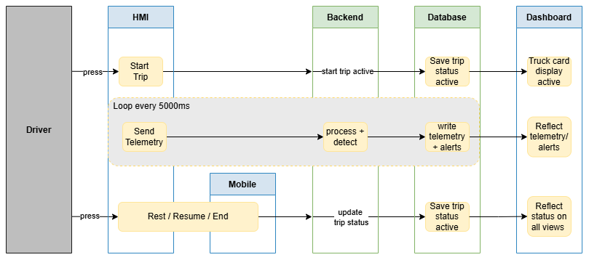Figure 5.6b. Cross-Interface State-Synchronization Sequence Diagram
Figure 5.6b illustrates the cross-interface synchronization flow of the system, depicting how data propagates across the HMI, backend, database, and dashboard layers in response to driver actions. When the driver initiates a trip via the HMI or mobile app, the backend creates an active trip record in trip_sessions, which simultaneously triggers the truck card display to activate on the dashboard. Telemetry data is transmitted every 5000 milliseconds as a cycle during a trip. Consequently, each cycle is processed and anomaly detected by the backend before it is recorded in telemetry_logs and displayed as alerts in the dashboard. The trip status changes are also reflected throughout the system through trip_sessions.trip_status for the Rest, Resume or End of trip status. This mechanism ensures that all interfaces, including the mobile PWA and HMI poll-back, remain synchronized with the current session state. Throughout this process, trip_sessions functions as the canonical source of trip data and the authoritative state controller for the entire architecture, serving as the definitive reference point for maintaining consistency across all system interfaces through the centralized database.
Section 5.6.6 - odometer methodology:
The Toyota Hilux vehicles used in the prototype display lifetime mileage on the physical dashboard, but that value is not exposed through the OBD-II adapter available to the system. The firmware probes the Toyota-specific Mode 21 and Mode 22 odometer data identifiers, but the fleet does not return a usable lifetime odometer value; as a result, telemetry_logs.odometer_km is either null or a trip-scoped speed-integrated fallback generated by the HMI. It is not treated as an absolute lifetime odometer reading.
For this reason, backend lifetime mileage is computed from completed trip distance rather than from the raw OBD odometer field. Each active trip continually updates trip_sessions.distance_km through public.compute_trip_distance_km(p_trip_id), implemented in backend/db/migration_distance_rpc_v3_jitter.sql. The function takes the greater of capped speed-by-time integration and filtered GPS haversine distance, rejecting stationary GPS jitter below the movement threshold. When a trip transitions to trip_status = 'ended', backend/server.js calls public.accumulate_trip_distance_odometer(p_trip_id), which adds that finalised distance_km to trucks.current_odometer_km exactly once and records trip_sessions.odometer_accumulated_at.
Section 5.6.7 - Table 5.6.2:
Table 5.6.2 - Alert Rule Thresholds (implemented)
Alert | Threshold | Trigger source | Hardware action
Rest reminder | distance >= 300 km AND drive time >= 4 h | backend /device/alerts | HMI buzzer, screen alert, 'Take Rest' button
Maintenance (oil) | trip distance >= 5,000 km | backend trip aggregation | Dashboard banner + planned email/push
Overspeed | speed >= 100 km/h | telemetry stream | HMI flash and log
Fuel anomaly | ML flag from Isolation Forest or Matrix Profile | anomaly_service.py | Dashboard alert card
Source: backend/server.js:240-251.
Section 5.6.7 - Table 5.6.3:
Table 5.6.3 - Extended Safety Implementation Status
Safety alert | Status | Implementation note
Overspeed | Implemented | backend/server.js:758-772, threshold 100 km/h
Rest reminder | Implemented | SO5-b spec is 300 km / 6 h; implemented at 4 h per LTO driver-fatigue reading
Maintenance (5,000 km) | Implemented | backend/server.js:879-894
Harsh acceleration / braking | Partial | acceleration_kmph_per_sec computed at ml/preprocess.py:74; no alert rule yet
Lane departure | Out of scope | Requires camera and IMU - future work
Fatigue / drowsiness | Out of scope | Requires camera with face detection - future work

5.7 Machine Learning Methodology
Section 5.7 - required sub-structure:
· 5.7.1 ML architecture (Figure 5.7.1, below)
· 5.7.2 Dataset composition (Table 5.7.1, below)
· 5.7.3 Anomaly injection methodology
· 5.7.4 Anomaly scenario coverage (Table 5.7.2, below)
· 5.7.5 Feature engineering (Table 5.7.3, below)
· 5.7.6 Isolation Forest training methodology
· 5.7.7 Matrix Profile methodology
· 5.7.8 Hybrid fusion methodology
· 5.7.9 Contextual gate methodology
· 5.7.10 Live deployment integration
The anomaly-detection pipeline uses Isolation Forest Model C as the primary production detector and Matrix Profile as a supporting subsequence detector. Model C receives context-aware features derived from fuel level, speed, distance, engine operation, driver behavior, route context, and fuel-economy baseline deviation. Matrix Profile is retained to support detection of gradual subsequence-level fuel-loss patterns. Model performance is evaluated using leave-one-trip-out validation so each held-out trip is scored by models trained and calibrated on separate trips.
Section 5.7.1 - Figure 5.7.1:
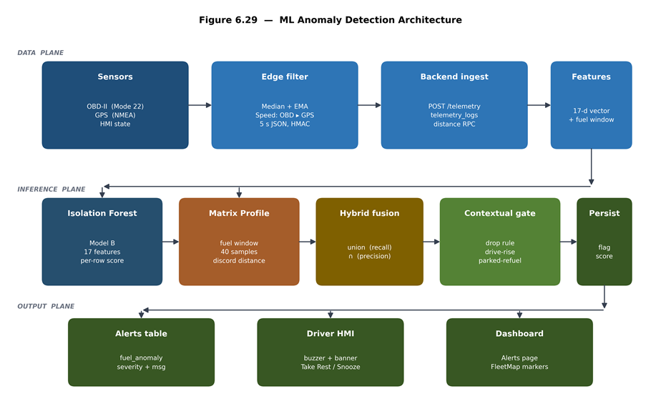
Figure 5.7.1 - ML Anomaly Detection Architecture. Four-row pipeline: (Row 1) sensor sources -> edge preprocessing -> backend ingest -> Supabase; (Row 2) 33-feature engineered vector for Model C; (Row 3) dual-model inference (IF row-level + MP discord, hybrid fusion); (Row 4) downstream consumers (anomaly_flag/anomaly_score persisted, alerts INSERT, HMI buzzer + banner, React dashboard).
Section 5.7.2 - Table 5.7.1:
Table 5.7.1 - Dataset Composition (evaluation corpus)
Dimension | Value
Volume
Total telemetry rows | 20,412
Total trips | 79
Anomalous trips | 6
Normal samples (clean) | 20,327
Anomalous samples (labelled) | 85
Source partition
public_geolife_route_derived_fuel | 19,778 rows
project_native (prototype-captured) | 634 rows
Label class
clean_public_route | 19,778 rows
clean (project-native) | 465 rows
controlled_injection | 169 rows
Evaluation subset
public_clean (out-of-distribution) | 19,778 rows
project_native_clean (in-distribution baseline) | 465 rows
project_native_injected (headline target) | 169 rows
Trip length distribution
Short trips (< 12 min) | 30
Medium trips (12-30 min) | 31
Long trips (> 30 min) | 18

Sources: ml/reports/evaluation_dataset_summary.json, evaluation_report.txt, thesis_defense_summary.json.
Section 5.7.3 - anomaly injection methodology:
Controlled-injection anomalies were applied to the project-native partition by ml/inject_anomalies.py across three industry-documented patterns: sudden_fuel_drop (single-step drop of at least 10 %), abnormal_rapid_decrease (4-sample drop window), and gradual_leak (slow steady decrease at <1 % per step). 76 of the 85 labelled rows are gradual_leak by design, because gradual leaks are the hardest detection regime - each row sits inside the sensor-noise envelope - and the injection budget deliberately weights toward that class.
Section 5.7.4 - Table 5.7.2:
Table 5.7.2 - Anomaly Scenario Coverage
Scenario | Description | Primary detector | Coverage
Sudden fuel theft | Single-step drop of at least 10 % | Isolation Forest | Yes
Gradual siphoning | Slow steady decrease | Matrix Profile | Yes
Continuous leak | Linear decline at speed = 0 | Matrix Profile | Yes
Sensor spike | Brief out-of-range raw value | Median filter (pre-ML) | Yes
Heavy legitimate consumption | Loaded uphill drive | Both models correctly classify as normal | Yes
Source: controlled-injection scenario definitions in ml/simulate_scenarios.py.
Section 5.7.5 - Table 5.7.3:
Table 5.7.3 - Feature Set Across Isolation Forest Variants (A / B / C)
# | Feature | Source signal | What it captures | A | B | C
1 | fuel_level_filtered | OBD-II PID 21/29 | Baseline tank level after filter cascade | Y | Y | Y
2 | speed_filtered | OBD-II PID 0x0D + GPS fallback | Smoothed vehicle speed | Y | Y | Y
3 | fuel_delta | fuel_level_filtered | Per-row consumption increment | Y | Y | Y
4 | odometer_delta | OBD-II odometer / integrated speed | Distance moved per sample | Y | Y | Y
5 | fuel_per_km | fuel_delta / odometer_delta | Efficiency rate - siphoning under load | Y | Y | Y
6 | fuel_rate_per_hour | fuel_delta / dt | Continuous-leak signature | Y | Y | Y
7 | distance_per_fuel | 1 / fuel_per_km | Light-load / coasting regime | Y | Y | Y
8 | route_segment_performance | Per-segment mean vs trip mean | Route-specific consumption shift | Y | Y | Y
9 | driver_behavior_score | Aggregate of accel + variability + idle | Long-tail driving-style signal | Y | Y | Y
10 | engine_rpm_normalized | OBD-II PID 0x0C | Engine work intensity | Y | Y | Y
11 | engine_load_pct_norm | OBD-II PID 0x04 | ECU-reported load fraction | Y | Y | Y
12 | throttle_pct_norm | OBD-II PID 0x11 | Driver demand | Y | Y | Y
13 | fuel_drop_while_stationary | fuel_delta + speed | Siphoning signature - drop while parked | Y | Y | Y
14 | fuel_drop_with_engine_off | fuel_delta + engine_status | Theft-at-rest signature | Y | Y | Y
15 | idle_duration_score | Rolling 5-row idle flag sum | Sustained-idle context for parked-refuel logic | Y | Y | Y
16 | fuel_drop_per_rpm | fuel_per_km / rpm_norm | Disagreement: fuel use vs engine work | Y | Y | Y
17 | fuel_drop_per_load | fuel_per_km / engine_load_norm | Disagreement: fuel use vs reported load | Y | Y | Y
18 | motion_state_code | speed + engine_status | Motion-regime category for slosh suppression | Y | Y | Y
19 | time_since_refuel_norm | refuel-event detector | Refuel-window exemption signal | Y | Y | Y
20 | post_refuel_flag | refuel-event detector | Hard-coded 60-sample refuel exemption | Y | Y | Y
21 | delta_engine_load_norm | engine_load_pct_norm Delta | Rate of change of load | Y | Y | Y
22 | delta_throttle_norm | throttle_pct_norm Delta | Rate of change of driver input | Y | Y | Y
23 | load_per_speed_norm | load / speed | Load relative to motion - high load while parked | Y | Y | Y
24 | expected_consumption_residual | physics-model vs observed | Slosh-suppression baseline | Y | Y | Y
25 | rpm_high_share | engine_rpm_normalized | Rolling fraction with RPM > 2000 (Barbado high band) | - | Y | Y
26 | rpm_red_share | engine_rpm_normalized | Rolling fraction with RPM > 3500 (red band) | - | Y | Y
27 | rpm_orange_share | engine_rpm_normalized | Rolling fraction 2500-3500 (orange band) | - | Y | Y
28 | rpm_yellow_share | engine_rpm_normalized | Rolling fraction 1500-2500 (yellow band) | - | Y | Y
29 | speed_over_90_share | speed_filtered | Rolling fraction with speed > 90 km/h | - | Y | Y
30 | speed_over_120_share | speed_filtered | Rolling fraction with speed > 120 km/h | - | Y | Y
31 | kmpl_deviation_pct | per-asset fuel-economy baseline | Per-asset fuel-economy deviation | - | - | Y
32 | driver_kmpl_deviation_pct | per-driver fuel-economy baseline | Per-driver fuel-economy deviation | - | - | Y
33 | route_type_code | trip metadata + GPS context | Route-context disambiguator for KMPL features | - | - | Y

Sources: ml/preprocess.py (CONTEXT_FEATURE_COLUMNS_V2, DRIVING_ZONE_FEATURE_COLUMNS, KMPL_DEVIATION_FEATURE_COLUMNS); embedded/hmi_phase1/src/main.cpp:4286-4445 (telemetry schema); ml/anomaly_service.py:128 (inference endpoint).
Model A = 24 features (context-aware baseline). Model B = 30 features (+ Barbado driving zones, ablation only). Model C = 33 features (+ Habib KMPL baseline deviation, PRODUCTION).
Section 5.7.6 - Isolation Forest training methodology:
The Isolation Forest is trained with contamination = 0.015 (theft is genuinely rare in fleet operation, prior ~1-2 %), n_estimators = 300 (default sklearn balance per Barbado §4.3), and max_samples = 256 (Liu, Ting, Zhou 2008 original IF paper). The score threshold for each leave-one-trip-out fold is the 0.985 quantile of the fold's clean training scores; the choice is internally consistent with the contamination = 0.015 hyperparameter (both expect the same 1.5 % nominal anomaly fraction at the boundary) and avoids any hand-tuned magic number. No precision margin and no per-context shimming are applied.
Section 5.7.7 - Matrix Profile methodology:
Matrix Profile v2 is implemented in ml/matrix_profile.py with the post-discord magnitude gate (>=1 % absolute fuel change), direction gate (downward-only), and refuel-exemption gate calibrated against the held-out clean project-native trips at each LOTO fold. The narrow discord window (m = 4 samples) is intentional - it preserves subsequence sensitivity for slow-leak signatures - and explains why the strict row-level IF AND MP intersection collapses to roughly 5 % recall and is rejected as a deployment definition.
Section 5.7.8 - hybrid fusion methodology:
Two fusion strategies are characterised in ml/infer.py:run_combined_inference(). The Hybrid Union (IF OR MP) maximises recall. The Hybrid Intersection used for production alerting is a trip-level MP gate over row-level IF predictions: a row is flagged if and only if (a) the Isolation Forest flagged that row AND (b) the trip's overall Matrix Profile decision was 'anomalous shape detected'. The trip-gated definition preserves the precision intent of the intersection while avoiding the granularity-mismatch penalty of strict row-level AND.
Section 5.7.9 - contextual gate methodology:
The contextual gate at backend/server.js:3048-3063 receives every row flagged by the ML layer and applies three deterministic rules - drop (suppress repeated flags inside the same window), drive-rise (suppress flags during legitimate post-acceleration recovery), and parked-refuel (suppress flags during the 5-minute post-refuel quiescence window) - before deciding whether to insert an alert row. Across the 37.7-day live deployment the gate rejected 75.1 % of model flags, reducing the user-facing alert rate from 2.90 % to 0.72 %.
Section 5.7.10 - live deployment integration:
The ML service is a Flask microservice at ml/anomaly_service.py exposing POST /detect. After each /telemetry insert the backend invokes /detect via setImmediate; the result is written back to telemetry_logs.anomaly_flag, anomaly_score, and model_source, and a row is appended to the alerts table with alert_type = 'fuel_anomaly' when the contextual gate permits.

5.8 Evaluation Methodology
Section 5.8 - LOTO methodology paragraph (RELOCATED FROM CH.6 §6.4.3):
All Chapter 6 SO4 numbers are produced by a leave-one-trip-out (LOTO) evaluation that holds the calibration set strictly disjoint from the test set. For each of the twelve project-native trips, the three Isolation Forest variants and the Matrix Profile detector are refit and recalibrated on the clean rows of the remaining eleven project-native trips only; the held-out trip is then scored with that fold's models. Each prediction is therefore strictly out-of-sample with respect to both model fitting and threshold calibration - an audit a panel can reproduce against the artefacts in ml/loto_evaluate.py to confirm no test-set leakage. The Isolation Forest threshold for every variant is the 0.985 quantile of the fold's clean training scores, internally consistent with the contamination = 0.015 hyperparameter; no precision margin and no per-context shimming are applied.
Section 5.8 - evaluation methodology master table:
Table 5.8.1 - Objective -> Protocol -> Metric
Objective | Evaluation protocol | Metric
SO1 - Fuel accuracy | Dashboard-gauge walkaround pairs (Table 6.1) + per-tank-band drift/noise/jitter on n=20,363 valid samples (Table 6.3) | MAPE, max error, mean abs. noise (%), drift @ speed=0
SO2 - Communication | LoRa distance test (10 m..5 km), GSM/LTE drive test at 5 locations, 3-region packet-delivery drive (urban/highway/dead-zone) | Median + p95 latency, packet-success fraction, SPIFFS-replay share, RSSI/SNR per band
SO3 - GPS | sent_at interval analysis on live telemetry; GPS fix-availability; route vs OSRM polyline comparison | Median + p95 inter-sample dt, fix availability (%), per-segment fuel (% per km)
SO4 - ML | LOTO cross-validation on project_native_injected + threshold/IQR baseline + Hybrid Union/Intersection ablation + OOD stress test on public_clean + 37.7-day live deployment audit | Precision, recall, FPR, F1, Wilson 95 % CI, per-model confusion matrices, live alert-resolution rate
SO5 - Alerts | Alert-trigger verification across controlled-environment trip set (methodology_snippets.md §3.X) | Trigger correctness (TP rate), driver-response capture, HMI/dashboard/mobile sync correctness

Chapter 5

5.1 Opening Paragraph
The system architecture is an edge-to-cloud fleet-monitoring pipeline in which the embedded HMI performs data acquisition, filtering, trip-state handling, local driver display, and prioritized transmission. The backend stores telemetry, synchronizes state across three concurrent client surfaces - the in-truck HMI, the mobile driver web application, and the administrative dashboard - and dispatches anomaly and safety alerts through the same database tables subscribed to by the three surfaces.

5.3 OBD-II/ECU Data Acquisition Paragraph
Fuel level was acquired through the Toyota meter Mode 22 PID 21/29 channel of the OBD-II interface. The same telemetry cycle also captured contextual OBD-II variables such as speed, engine RPM, engine load, throttle position, mass air flow, coolant temperature, engine runtime, and diagnostic-trouble-code status. These fields were timestamped at the device and transmitted to the backend together with GPS, trip-state, and communication-channel metadata so that the anomaly detector could interpret fuel changes in relation to vehicle operation rather than fuel percentage alone.

5.4 Fuel Preprocessing Paragraph
The raw OBD-II fuel reading was passed through a multi-stage edge filter before publication. A median window rejects single-sample spikes caused by slosh and sender chatter; an exponential moving average smooths residual noise; a dead-band publisher prevents display jitter; and a direction-aware step rule permits downward movement consistent with fuel burn while rejecting upward movement during motion unless a stationary refuel signature is observed. This filtered value is the fuel percentage displayed on the HMI and stored in telemetry_logs.

5.5 Communication Fall-Through Paragraph
Each telemetry record is attempted on the highest-priority available channel: LoRa first when a gateway is reachable, then LTE, GSM 2G, WiFi, and finally the SPIFFS offline buffer. A failed transmission falls through to the next channel without changing the sequence number or event identifier. If all real-time channels fail, the record is appended to the local SPIFFS buffer and replayed once any channel recovers. Replayed records are tagged as offline_replay so the backend can distinguish delayed telemetry from live telemetry.

5.6 Cross-Interface Sync Paragraph
Trip state is centralized in the backend through trip_sessions. When a driver starts, pauses, resumes, or ends a trip from the HMI or mobile web app, the backend updates the authoritative trip state and the dashboard, mobile app, and HMI poll-back logic mirror that state. Partial unique indexes enforce one active trip per truck and one active trip per driver, preventing duplicate active-trip sessions across the three interfaces.

5.7 ML Methodology Paragraph
The anomaly-detection pipeline uses Isolation Forest Model C as the primary production detector and Matrix Profile as a supporting subsequence detector. Model C receives context-aware features derived from fuel level, speed, distance, engine operation, driver behavior, route context, and fuel-economy baseline deviation. Matrix Profile is retained to support detection of gradual subsequence-level fuel-loss patterns. Model performance is evaluated using leave-one-trip-out validation so each held-out trip is scored by models trained and calibrated on separate trips.

5.1 System Architecture and Conceptual Design
--- READY-TO-PASTE INTO CHAPTER 5 ---
Section 5.1 - opening paragraph:
The system architecture is an edge-to-cloud fleet-monitoring pipeline in which the embedded HMI performs data acquisition, filtering, trip-state handling, local driver display, and prioritised transmission. The backend stores telemetry, synchronises state across three concurrent client surfaces - the in-truck HMI, the mobile driver web application, and the administrative dashboard - and dispatches anomaly and safety alerts through the same database tables that the three surfaces subscribe to.

Figure 5.1 - End-to-end system architecture: truck OBD-II -> ESP32 HMI -> LoRa / LTE / GSM / WiFi / SPIFFS -> backend (Node/Express on Render) -> Supabase Postgres -> ML service -> dashboard + mobile app + HMI poll-back.
Section 5.1 - data-flow walkthrough:
Truck ECU (OBD-II Mode 22 PID 21/29 fuel + Mode 01 speed/RPM/load/...)
v
ESP32 HMI (main.cpp)
- filter cascade (median-31 -> EMA -> dead-band -> direction-aware)
- trip state machine (Loading / Active / Paused / Ended)
- GPS / OBD distance fusion (distance_*_delta_km columns)
v
Comm steering: LoRa -> LTE -> GSM -> WiFi -> SPIFFS
v
Backend /telemetry POST (server.js)
- telemetry_logs INSERT
- setImmediate -> ML /detect
- contextual gate -> alerts INSERT
v
Supabase Postgres -> Dashboard + Mobile PWA + HMI poll-back
--- END PASTE BLOCK ---

5.2 Hardware Methodology
--- READY-TO-PASTE INTO CHAPTER 5 ---
Section 5.2 - required content:
· ESP32 (dual-core 240 MHz, VSPI/HSPI bus separation - this is what cured the 2026-05-30 LoRa/TFT IDF deadlock via xPortGetCoreID() guard).
· ILI9341 2.4" TFT (VSPI / Core 1) + XPT2046 touch + UI buttons + buzzer.
· OBD-II / CAN interface (MCP2515 + transceiver) on UART.
· A7670E LTE/GSM modem on UART (PWRKEY on GPIO 5).
· SX1278 LoRa transceiver on VSPI (Core 0 guarded).
· GPS module on UART.
· Power + decoupling network.
Section 5.2.1 - GPIO map (moved from Ch.6 §6.5.2):
Table 5.2.1 - HMI GPIO Map
Pin | Function
GPIO 22 | BTN_TAKE_REST (active-low, debounced 50 ms)
GPIO 39 | BTN_SNOOZE (active-low, debounced 50 ms)
GPIO 25 | Buzzer (PWM through the LEDC peripheral)
GPIO 5 | A7670E modem PWRKEY

Source: embedded/hmi_phase1/src/main.cpp:62-64.
Owner action: MONTEMAYOR draws Figure 5.2 (ESP32 Hardware Block Diagram) in Figma/Fritzing/draw.io and exports to docs/results/so2_comm/fig_5_2_hardware_block.png.
--- END PASTE BLOCK ---

5.3 OBD-II / ECU Fuel and Vehicle Data Acquisition Methodology
--- READY-TO-PASTE INTO CHAPTER 5 ---
Section 5.3 - required structure:
· 5.3.1 Physical interface - OBD-II port, ISO 15765-4 transport.
· 5.3.2 Toyota meter Mode 22 PID 21/29 fuel acquisition (0.5 L per ADC count, 1.5 s polling cadence, NACK retry policy).
· 5.3.3 Co-acquired Mode 01 PIDs - mapping to telemetry_logs columns:
Table 5.3.1 - OBD-II PID to telemetry_logs column mapping
PID | Quantity | Telemetry column
Mode 22 0x21 0x29 | Fuel sender voltage (0.5 L per ADC count) | fuel_level (filtered) + fuel_source='mode22' + fuel_confidence
Mode 01 0x0C | Engine RPM | engine_rpm
Mode 01 0x0D | Vehicle speed (km/h) | speed
Mode 01 0x04 | Calculated engine load (%) | engine_load_pct
Mode 01 0x11 | Throttle position (%) | throttle_pct
Mode 01 0x10 | Mass air flow (g/s) | maf_gps
Mode 01 0x05 | Engine coolant temperature (degC) | coolant_temp_c
Mode 01 0x1F | Time since engine start (s) | engine_runtime_sec
Mode 03 / 0x01 | Stored DTCs (count + presence) | dtc_present, dtc_count

· 5.3.4 Validity / confidence fields (fuel_valid, fuel_source, fuel_confidence) - all written every telemetry cycle.
· 5.3.5 Timestamping (device-side original_device_timestamp vs backend-side timestamp; server_now reconciliation).
· 5.3.6 Field-reference choice (manufacturer dashboard gauge - justified in Ch.1 delimitations because dipstick not permitted).
--- END PASTE BLOCK ---

5.4 Fuel Preprocessing Methodology
--- READY-TO-PASTE INTO CHAPTER 5 ---

Figure 5.4 - Fuel-level filter cascade. The raw OBD-II Mode 22 PID 21/29 fuel sample (every 1.5 s) is passed through a five-stage cascade: median-of-31 -> EMA (alpha = 0.04) -> dead-band publisher -> direction-aware step rule -> post-refuel quiescence freeze. The published percentage feeds the HMI display and the telemetry stream.
Section 5.4 - cascade specification:
Raw OBD-II Toyota Mode 22 PID 21/29 fuel value (every 1.5 s)
Stage 1: Median over 31 most-recent samples (~45 s memory)
Stage 2: EMA alpha = 0.04 (~110 s settling)
Stage 3: Dead-band publisher (anchor displayed % to floor(EMA))
Stage 4: Direction-aware step rule
DOWN allowed if EMA falls >= 2.5 % below anchor (real burn)
UP allowed only if EMA rises >= 10 % above anchor
AND vehicle stationary >= 60 s (refuel signature)
Stage 5: Post-refuel quiescence freeze for 5 min (REFUEL_QUIESCENCE_MS)
Published fuel % -> HMI display + telemetry_logs.fuel_level
Section 5.4 - warm-up rule:
The first three samples per trip session are withheld from publication and the human-machine interface displays the placeholder 'Loading' until the median window has been populated, preventing a noisy first read from anchoring the displayed value at an inaccurate level.
--- END PASTE BLOCK ---

5.5 Communication and Offline Sync Methodology

Section 5.5 - required sub-structure:
· 5.5.1 Priority chain rationale
· 5.5.2 Module comparison table (Table 5.5.1, below)
· 5.5.3 Method radar (Figure 5.5.1, below)
· 5.5.4 Telemetry JSON schema (below)
· 5.5.5 Buffer fall-through flowchart (Figure 5.5.2, below)
· 5.5.6 Fall-through policy paragraph (below)
· 5.5.7 Security (per-packet HMAC, HTTPS / TLS)
· 5.5.8 LoRa range protocol
· 5.5.9 GSM/LTE drive-test protocol
· 5.5.10 Packet-delivery and buffering protocol
Section 5.5.1 - priority chain rationale:
LTE was treated as the primary wide-area data path because it offers the lowest steady-state latency and highest payload throughput among the available wide-area options. LoRa was retained as the depot/yard and long-range telemetry path because of its multi-kilometre line-of-sight reach at very low power. GSM 2G was retained as the deeper-fallback for 2G-only coverage pockets on the Batangas and Subic routes. WiFi was retained as a depot or driver-tether path. SPIFFS offline-buffer replay is the final fallback that guarantees no telemetry record is silently lost when all four real-time channels are unavailable.
Section 5.5.2 - Table 5.5.1 (RELOCATED FROM CH.6 §6.2.3):
Table 5.5.1 - Communication Module Comparison
Module | Technology | Hardware | Bandwidth | Range | Power | Role
WiFi | 802.11 b/g/n | ESP32 built-in | ~10 Mbps | ~50 m | Low | Depot and driver hotspot
LTE | LTE Cat-1 | A7670E | ~10 Mbps | Cell coverage | Medium | Primary cellular path
GSM 2G | EDGE | A7670E fallback | ~80 kbps | Wider than LTE | Medium | Cellular fallback
LoRa | SX1278, 433 MHz, SF7, BW 125 kHz | RA-02, 17 dBm TX | ~5.5 kbps | ~50 m urban NLOS @ 97 % (measured); ~1 km open LOS @ 60 % (measured); up to 10 km LOS per SX1278 datasheet | Very low | Primary telemetry path (intelligent traffic-steering chain)
Offline | - | SPIFFS flash | - | - | None | Outage replay

Sources: main.cpp:78-102 (LoRa parameters), main.cpp:47-52 (modem UART). The LoRa range column is reported as two values - the operational urban NLOS reach measured in this study and the line-of-sight reach published in the SX1278 datasheet. LoRa is the highest-priority transport in the intelligent-traffic-steering chain (LoRa -> LTE -> GSM 2G -> WiFi -> SPIFFS buffer); the cellular path provides coverage of the urban-NLOS regime past ~50 m where LoRa delivery degrades.
Section 5.5.3 - Figure 5.5.1 (RELOCATED FROM CH.6 §6.2.8):

Figure 5.5.1 - Communication Method Comparison radar. Five channels (LoRa / LTE / GSM 2G / WiFi / SPIFFS) compared on six axes - range, bandwidth, power efficiency, Philippine coverage, infrastructure independence, data integrity - normalised to a five-point scale.
Section 5.5.4 - telemetry JSON schema:
{
"truck_id": "<uuid>",
"driver_id": "<uuid>",
"trip_id": "<uuid>",
"sent_at": "<iso-8601>",
"original_device_timestamp": "<iso-8601>",
"source_device": "hmi" | "mobile",
"fuel_level": <0..100>, "fuel_valid": <bool>,
"fuel_source": "...", "fuel_confidence": <0..1>,
"lat": <float>, "lon": <float>,
"gps_source": "embedded_gps" | "mobile_gps" | "fused_mobile_fallback",
"gps_accuracy_m": <float>, "gps_heading_deg": <float>,
"mobile_speed_mps": <float>,
"speed": <km/h>, "odometer_km": <float>,
"engine_status": "on" | "off" | "idle",
"seq": <bigint>, "event_id": "<uuid>",
"channel_used": "lora"|"gsm"|"offline_replay"|"mobile_app"|"simulation",
"comm_channel": "...",
"hmi_driving_sec": <int>, "hmi_rest_sec": <int>, "hmi_trip_status": "...",
"engine_rpm": <int>, "engine_load_pct": <float>, "throttle_pct": <float>,
"maf_gps": <float>, "coolant_temp_c": <float>, "engine_runtime_sec": <int>,
"dtc_present": <bool>, "dtc_count": <int>,
"distance_gps_delta_km": <float>, "distance_obd_delta_km": <float>,
"distance_fused_delta_km": <float>
}
Section 5.5.5 - Figure 5.5.2 (RELOCATED FROM CH.6 §6.2.8):

Figure 5.5.2 - Offline-buffer fall-through flowchart. The decision tree executed by the Core 0 worker each five-second sample cycle: a telemetry sample is first routed through the highest-priority online channel; on a non-2xx response the worker falls through to the next channel and, if all channels are exhausted, appends the record to /tel_buf.log. The buffer drains on a five-second cadence with a guaranteed-forward-progress minimum of one record per worker pass.
Section 5.5.6 - fall-through policy paragraph:
Each telemetry record is attempted on the highest-priority available channel - LoRa first if a gateway uplink is in range, otherwise LTE, then GSM 2G, then WiFi. If an attempt fails (non-2xx response from the backend or modem emrror), the firmware falls through to the next channel without duplicating the seq or event_id. If all real-time channels fail, the record is appended to the SPIFFS ring buffer and replayed once any channel recovers; the replayed record is tagged channel_used = 'offline_replay' so the backend can distinguish live from replayed data. HMAC signing of the payload and HTTPS / TLS transport protect the telemetry against tampering and eavesdropping on the cellular path.
Section 5.5.8/9/10 - protocols (paste verbatim from methodology_snippets.md):
5.5.8 LoRa range test protocol. The LoRa physical-layer range test was conducted with the SX1278 module configured at seventeen-dBm transmit power, four-hundred-thirty-three-megahertz centre frequency, spreading factor seven, and one-hundred-twenty-five-kilohertz bandwidth. One hundred telemetry-sized packets were transmitted from the in-truck node to a fixed gateway at each of the open line-of-sight distances of ten, fifty, one hundred, two hundred and fifty, five hundred, one thousand, two thousand, and five thousand metres, and at the urban non-line-of-sight distances of one hundred, two hundred and fifty, and five hundred metres. The received-signal-strength indicator, the signal-to-noise ratio, and the successfully-received-packet count were recorded at the gateway for each distance band.
5.5.9 GSM / LTE drive-test protocol. Carrier-reported signal quality was logged via the AT+CSQ command issued to the A7670E modem at five locations of operational interest: the depot, a Metro Manila urban environment, a highway corridor, a tunnel or underpass selected to trigger the buffer-activation path, and a provincial route in Batangas exhibiting two-gigahertz-only coverage. The per-packet upload latency was computed at the backend as the difference between the device-side sent_at timestamp and the backend-side receipt timestamp; the fiftieth- and ninety-fifth-percentile latencies are reported per location alongside the successful-upload fraction.
5.5.10 Packet-delivery and buffering protocol. A drive route was executed that traversed three distinct connectivity regions: an urban region with strong LTE coverage, a highway region with marginal LTE coverage, and a confirmed no-signal dead zone. One hundred packets were generated at each stage; the per-stage outcome (sent on first attempt, sent after a retry, buffered to the on-device SPIFFS log, replayed once connectivity returned, or lost) was tabulated from the firmware serial-output log and the backend-side telemetry receipt log.
--- END PASTE BLOCK ---

5.6 Backend and Database Methodology
--- READY-TO-PASTE INTO CHAPTER 5 ---
Section 5.6 - required sub-structure:
· 5.6.1 Backend stack (Node/Express on Render + Supabase Postgres).
· 5.6.2 Schema table (below).
· 5.6.3 ERD diagram (to be produced).
· 5.6.4 Cross-interface trip-sync flow (below).
· 5.6.5 Active-trip uniqueness enforcement.
· 5.6.6 Odometer and trip-distance methodology (absorbed §6.2.9).
· 5.6.7 Alert rule engine (Tables 5.6.2 and 5.6.3 below).
· 5.6.8 Archival pipeline.
Section 5.6.2 - Table 5.6.1 (DB schema):
Table 5.6.1 - Supabase Postgres schema (from backend/db/schema.sql)
Table | Purpose | Key columns
users | Accounts (head_admin / fleet_manager / manager / driver) | id, role, assigned_truck_id
trucks | Vehicle profile + maintenance state | id, truck_code, plate_number, current_odometer_km, status
trip_sessions | Active / paused / ended trips with destination, route polyline, nav state, mobile-GPS columns | id, truck_id, driver_id, trip_status, distance_km, assigned_destination, route_steps, mobile_lat/lon
telemetry_logs | Per-cycle fuel + GPS + OBD context + anomaly flag | fuel_level, lat/lon, speed, odometer_km, channel_used, anomaly_flag, anomaly_score, model_source
archived_telemetry_logs | Older trip telemetry beyond retention window | same as telemetry_logs + archived_at + archive_reason
trip_summaries | Per-trip aggregates upserted by refresh_trip_summary() RPC | total_distance_km, total_alerts, total_anomalies, average_fuel_level
alerts | Rest / maintenance / overspeed / low_fuel / fuel_anomaly events | alert_type, severity, is_resolved, trip_id
latency_logs | SO2-c latency tracking (sent_at vs received_at) | latency_ms, channel_used, retry, sent_at, received_at

Section 5.6.3 ERD diagram

Figure 5.6 ERD Diagram
Figure 5.6 presents the Entity-Relationship Diagram (ERD) of the system's Supabase PostgreSQL database, containing eight interrelated tables: trucks, users, trip_sessions, telemetry_logs, archived_telemetry_logs, trip_summaries, alerts, and latency_logs. The trip_sessions table serves as the main hub for the relationships among these tables, linking trucks (truck_id) and drivers (driver_id). The other tables such as telemetry_logs, archived_telemetry_logs, trip_summaries, alerts and latency_logs, reference the trip by trip_id in order to relate records in the respective tables to a specific trip session. This data structure is designed to maintain referential integrity throughout the schema and support scalable access to the HMI dashboard, mobile app, and backend analytic pipeline.

Section 5.6.4 - cross-interface sync flow:
Driver presses Start Trip on HMI (or mobile app)
v
Backend POST /trip/start -> trip_sessions INSERT (trip_status='active')
uniq_one_active_trip_per_truck and ..._per_driver enforce 1-active
v
Mobile PWA poll /trip/active -> shows assigned route + ETA
Dashboard subscription -> truck card switches to 'active'
v
Telemetry stream every TELEMETRY_INTERVAL_MS = 5000 ms
/telemetry POST -> telemetry_logs INSERT
setImmediate -> anomaly_service /detect
-> contextual gate at backend/server.js:3048-3063
-> alerts INSERT (fuel_anomaly | rest_alert | maintenance |
low_fuel | overspeed)
v
Rest / Resume / End propagate through trip_sessions.trip_status
mirrored by HMI poll-back + mobile + dashboard
Figure 5.6b. Cross-Interface State-Synchronization Sequence Diagram
Figure 5.6b illustrates the cross-interface synchronization flow of the system, depicting how data propagates across the HMI, backend, database, and dashboard layers in response to driver actions. When the driver initiates a trip via the HMI or mobile app, the backend creates an active trip record in trip_sessions, which simultaneously triggers the truck card display to activate on the dashboard. Telemetry data is transmitted every 5000 milliseconds as a cycle during a trip. Consequently, each cycle is processed and anomaly detected by the backend before it is recorded in telemetry_logs and displayed as alerts in the dashboard. The trip status changes are also reflected throughout the system through trip_sessions.trip_status for the Rest, Resume or End of trip status. This mechanism ensures that all interfaces, including the mobile PWA and HMI poll-back, remain synchronized with the current session state. Throughout this process, trip_sessions functions as the canonical source of trip data and the authoritative state controller for the entire architecture, serving as the definitive reference point for maintaining consistency across all system interfaces through the centralized database.
Section 5.6.6 - odometer methodology (paste from Ch.6 §6.2.9):
The Toyota Hilux vehicles used in the prototype display lifetime mileage on the physical dashboard, but that value is not exposed through the OBD-II adapter available to the system. The firmware probes the Toyota-specific Mode 21 and Mode 22 odometer data identifiers, but the fleet does not return a usable lifetime odometer value; as a result, telemetry_logs.odometer_km is either null or a trip-scoped speed-integrated fallback generated by the HMI. It is not treated as an absolute lifetime odometer reading.
For this reason, backend lifetime mileage is computed from completed trip distance rather than from the raw OBD odometer field. Each active trip continually updates trip_sessions.distance_km through public.compute_trip_distance_km(p_trip_id), implemented in backend/db/migration_distance_rpc_v3_jitter.sql. The function takes the greater of capped speed-by-time integration and filtered GPS haversine distance, rejecting stationary GPS jitter below the movement threshold. When a trip transitions to trip_status = 'ended', backend/server.js calls public.accumulate_trip_distance_odometer(p_trip_id), which adds that finalised distance_km to trucks.current_odometer_km exactly once and records trip_sessions.odometer_accumulated_at.
Section 5.6.7 - Table 5.6.2 (RELOCATED FROM CH.6 §6.5.2):
Table 5.6.2 - Alert Rule Thresholds (implemented)
Alert | Threshold | Trigger source | Hardware action
Rest reminder | distance >= 300 km AND drive time >= 4 h | backend /device/alerts | HMI buzzer, screen alert, 'Take Rest' button
Maintenance (oil) | trip distance >= 5,000 km | backend trip aggregation | Dashboard banner + planned email/push
Overspeed | speed >= 100 km/h | telemetry stream | HMI flash and log
Fuel anomaly | ML flag from Isolation Forest or Matrix Profile | anomaly_service.py | Dashboard alert card

Source: backend/server.js:240-251.
Section 5.6.7 - Table 5.6.3 (RELOCATED FROM CH.6 §6.5.3):
Table 5.6.3 - Extended Safety Implementation Status
Safety alert | Status | Implementation note
Overspeed | Implemented | backend/server.js:758-772, threshold 100 km/h
Rest reminder | Implemented | SO5-b spec is 300 km / 6 h; implemented at 4 h per LTO driver-fatigue reading
Maintenance (5,000 km) | Implemented | backend/server.js:879-894
Harsh acceleration / braking | Partial | acceleration_kmph_per_sec computed at ml/preprocess.py:74; no alert rule yet
Lane departure | Out of scope | Requires camera and IMU - future work
Fatigue / drowsiness | Out of scope | Requires camera with face detection - future work

--- END PASTE BLOCK ---

5.7 Machine Learning Methodology
--- READY-TO-PASTE INTO CHAPTER 5 ---
Section 5.7 - required sub-structure:
· 5.7.1 ML architecture (Figure 5.7.1, below)
· 5.7.2 Dataset composition (Table 5.7.1, below)
· 5.7.3 Anomaly injection methodology
· 5.7.4 Anomaly scenario coverage (Table 5.7.2, below)
· 5.7.5 Feature engineering (Table 5.7.3, below)
· 5.7.6 Isolation Forest training methodology
· 5.7.7 Matrix Profile methodology
· 5.7.8 Hybrid fusion methodology
· 5.7.9 Contextual gate methodology
· 5.7.10 Live deployment integration
Section 5.7.1 - Figure 5.7.1 (RELOCATED FROM CH.6 §6.4.9):

Figure 5.7.1 - ML Anomaly Detection Architecture. Four-row pipeline: (Row 1) sensor sources -> edge preprocessing -> backend ingest -> Supabase; (Row 2) 33-feature engineered vector for Model C; (Row 3) dual-model inference (IF row-level + MP discord, hybrid fusion); (Row 4) downstream consumers (anomaly_flag/anomaly_score persisted, alerts INSERT, HMI buzzer + banner, React dashboard).
Section 5.7.2 - Table 5.7.1 (RELOCATED FROM CH.6 §6.4.2):
Table 5.7.1 - Dataset Composition (evaluation corpus)
Dimension | Value
Volume
Total telemetry rows | 20,412
Total trips | 79
Anomalous trips | 6
Normal samples (clean) | 20,327
Anomalous samples (labelled) | 85
Source partition
public_geolife_route_derived_fuel | 19,778 rows
project_native (prototype-captured) | 634 rows
Label class
clean_public_route | 19,778 rows
clean (project-native) | 465 rows
controlled_injection | 169 rows
Evaluation subset
public_clean (out-of-distribution) | 19,778 rows
project_native_clean (in-distribution baseline) | 465 rows
project_native_injected (headline target) | 169 rows
Trip length distribution
Short trips (< 12 min) | 30
Medium trips (12-30 min) | 31
Long trips (> 30 min) | 18

Sources: ml/reports/evaluation_dataset_summary.json, evaluation_report.txt, thesis_defense_summary.json.
Section 5.7.3 - anomaly injection methodology:
Controlled-injection anomalies were applied to the project-native partition by ml/inject_anomalies.py across three industry-documented patterns: sudden_fuel_drop (single-step drop of at least 10 %), abnormal_rapid_decrease (4-sample drop window), and gradual_leak (slow steady decrease at <1 % per step). 76 of the 85 labelled rows are gradual_leak by design, because gradual leaks are the hardest detection regime - each row sits inside the sensor-noise envelope - and the injection budget deliberately weights toward that class.
Section 5.7.4 - Table 5.7.2 (RELOCATED FROM CH.6 §6.4.5):
Table 5.7.2 - Anomaly Scenario Coverage
Scenario | Description | Primary detector | Coverage
Sudden fuel theft | Single-step drop of at least 10 % | Isolation Forest | Yes
Gradual siphoning | Slow steady decrease | Matrix Profile | Yes
Continuous leak | Linear decline at speed = 0 | Matrix Profile | Yes
Sensor spike | Brief out-of-range raw value | Median filter (pre-ML) | Yes
Heavy legitimate consumption | Loaded uphill drive | Both models correctly classify as normal | Yes

Source: controlled-injection scenario definitions in ml/simulate_scenarios.py.
Section 5.7.5 - Table 5.7.3 (RELOCATED FROM CH.6 §6.4.7):
Table 5.7.3 - Feature Set Across Isolation Forest Variants (A / B / C)
# | Feature | Source signal | What it captures | A | B | C
1 | fuel_level_filtered | OBD-II PID 21/29 | Baseline tank level after filter cascade | Y | Y | Y
2 | speed_filtered | OBD-II PID 0x0D + GPS fallback | Smoothed vehicle speed | Y | Y | Y
3 | fuel_delta | fuel_level_filtered | Per-row consumption increment | Y | Y | Y
4 | odometer_delta | OBD-II odometer / integrated speed | Distance moved per sample | Y | Y | Y
5 | fuel_per_km | fuel_delta / odometer_delta | Efficiency rate - siphoning under load | Y | Y | Y
6 | fuel_rate_per_hour | fuel_delta / dt | Continuous-leak signature | Y | Y | Y
7 | distance_per_fuel | 1 / fuel_per_km | Light-load / coasting regime | Y | Y | Y
8 | route_segment_performance | Per-segment mean vs trip mean | Route-specific consumption shift | Y | Y | Y
9 | driver_behavior_score | Aggregate of accel + variability + idle | Long-tail driving-style signal | Y | Y | Y
10 | engine_rpm_normalized | OBD-II PID 0x0C | Engine work intensity | Y | Y | Y
11 | engine_load_pct_norm | OBD-II PID 0x04 | ECU-reported load fraction | Y | Y | Y
12 | throttle_pct_norm | OBD-II PID 0x11 | Driver demand | Y | Y | Y
13 | fuel_drop_while_stationary | fuel_delta + speed | Siphoning signature - drop while parked | Y | Y | Y
14 | fuel_drop_with_engine_off | fuel_delta + engine_status | Theft-at-rest signature | Y | Y | Y
15 | idle_duration_score | Rolling 5-row idle flag sum | Sustained-idle context for parked-refuel logic | Y | Y | Y
16 | fuel_drop_per_rpm | fuel_per_km / rpm_norm | Disagreement: fuel use vs engine work | Y | Y | Y
17 | fuel_drop_per_load | fuel_per_km / engine_load_norm | Disagreement: fuel use vs reported load | Y | Y | Y
18 | motion_state_code | speed + engine_status | Motion-regime category for slosh suppression | Y | Y | Y
19 | time_since_refuel_norm | refuel-event detector | Refuel-window exemption signal | Y | Y | Y
20 | post_refuel_flag | refuel-event detector | Hard-coded 60-sample refuel exemption | Y | Y | Y
21 | delta_engine_load_norm | engine_load_pct_norm Delta | Rate of change of load | Y | Y | Y
22 | delta_throttle_norm | throttle_pct_norm Delta | Rate of change of driver input | Y | Y | Y
23 | load_per_speed_norm | load / speed | Load relative to motion - high load while parked | Y | Y | Y
24 | expected_consumption_residual | physics-model vs observed | Slosh-suppression baseline | Y | Y | Y
25 | rpm_high_share | engine_rpm_normalized | Rolling fraction with RPM > 2000 (Barbado high band) | - | Y | Y
26 | rpm_red_share | engine_rpm_normalized | Rolling fraction with RPM > 3500 (red band) | - | Y | Y
27 | rpm_orange_share | engine_rpm_normalized | Rolling fraction 2500-3500 (orange band) | - | Y | Y
28 | rpm_yellow_share | engine_rpm_normalized | Rolling fraction 1500-2500 (yellow band) | - | Y | Y
29 | speed_over_90_share | speed_filtered | Rolling fraction with speed > 90 km/h | - | Y | Y
30 | speed_over_120_share | speed_filtered | Rolling fraction with speed > 120 km/h | - | Y | Y
31 | kmpl_deviation_pct | per-asset fuel-economy baseline | Per-asset fuel-economy deviation | - | - | Y
32 | driver_kmpl_deviation_pct | per-driver fuel-economy baseline | Per-driver fuel-economy deviation | - | - | Y
33 | route_type_code | trip metadata + GPS context | Route-context disambiguator for KMPL features | - | - | Y

Sources: ml/preprocess.py (CONTEXT_FEATURE_COLUMNS_V2, DRIVING_ZONE_FEATURE_COLUMNS, KMPL_DEVIATION_FEATURE_COLUMNS); embedded/hmi_phase1/src/main.cpp:4286-4445 (telemetry schema); ml/anomaly_service.py:128 (inference endpoint).
Model A = 24 features (context-aware baseline). Model B = 30 features (+ Barbado driving zones, ablation only). Model C = 33 features (+ Habib KMPL baseline deviation, PRODUCTION).
Section 5.7.6 - Isolation Forest training methodology:
The Isolation Forest is trained with contamination = 0.015 (theft is genuinely rare in fleet operation, prior ~1-2 %), n_estimators = 300 (default sklearn balance per Barbado §4.3), and max_samples = 256 (Liu, Ting, Zhou 2008 original IF paper). The score threshold for each leave-one-trip-out fold is the 0.985 quantile of the fold's clean training scores; the choice is internally consistent with the contamination = 0.015 hyperparameter (both expect the same 1.5 % nominal anomaly fraction at the boundary) and avoids any hand-tuned magic number. No precision margin and no per-context shimming are applied.
Section 5.7.7 - Matrix Profile methodology:
Matrix Profile v2 is implemented in ml/matrix_profile.py with the post-discord magnitude gate (>=1 % absolute fuel change), direction gate (downward-only), and refuel-exemption gate calibrated against the held-out clean project-native trips at each LOTO fold. The narrow discord window (m = 4 samples) is intentional - it preserves subsequence sensitivity for slow-leak signatures - and explains why the strict row-level IF AND MP intersection collapses to roughly 5 % recall and is rejected as a deployment definition.
Section 5.7.8 - hybrid fusion methodology:
Two fusion strategies are characterised in ml/infer.py:run_combined_inference(). The Hybrid Union (IF OR MP) maximises recall. The Hybrid Intersection used for production alerting is a trip-level MP gate over row-level IF predictions: a row is flagged if and only if (a) the Isolation Forest flagged that row AND (b) the trip's overall Matrix Profile decision was 'anomalous shape detected'. The trip-gated definition preserves the precision intent of the intersection while avoiding the granularity-mismatch penalty of strict row-level AND.
Section 5.7.9 - contextual gate methodology:
The contextual gate at backend/server.js:3048-3063 receives every row flagged by the ML layer and applies three deterministic rules - drop (suppress repeated flags inside the same window), drive-rise (suppress flags during legitimate post-acceleration recovery), and parked-refuel (suppress flags during the 5-minute post-refuel quiescence window) - before deciding whether to insert an alert row. Across the 37.7-day live deployment the gate rejected 75.1 % of model flags, reducing the user-facing alert rate from 2.90 % to 0.72 %.
Section 5.7.10 - live deployment integration:
The ML service is a Flask microservice at ml/anomaly_service.py exposing POST /detect. After each /telemetry insert the backend invokes /detect via setImmediate; the result is written back to telemetry_logs.anomaly_flag, anomaly_score, and model_source, and a row is appended to the alerts table with alert_type = 'fuel_anomaly' when the contextual gate permits.
--- END PASTE BLOCK ---

5.8 Evaluation Methodology
--- READY-TO-PASTE INTO CHAPTER 5 ---
Section 5.8 - LOTO methodology paragraph (RELOCATED FROM CH.6 §6.4.3):
All Chapter 6 SO4 numbers are produced by a leave-one-trip-out (LOTO) evaluation that holds the calibration set strictly disjoint from the test set. For each of the twelve project-native trips, the three Isolation Forest variants and the Matrix Profile detector are refit and recalibrated on the clean rows of the remaining eleven project-native trips only; the held-out trip is then scored with that fold's models. Each prediction is therefore strictly out-of-sample with respect to both model fitting and threshold calibration - an audit a panel can reproduce against the artefacts in ml/loto_evaluate.py to confirm no test-set leakage. The Isolation Forest threshold for every variant is the 0.985 quantile of the fold's clean training scores, internally consistent with the contamination = 0.015 hyperparameter; no precision margin and no per-context shimming are applied.
Section 5.8 - evaluation methodology master table:
Table 5.8.1 - Objective -> Protocol -> Metric
Objective | Evaluation protocol | Metric
SO1 - Fuel accuracy | Dashboard-gauge walkaround pairs (Table 6.1) + per-tank-band drift/noise/jitter on n=20,363 valid samples (Table 6.3) | MAPE, max error, mean abs. noise (%), drift @ speed=0
SO2 - Communication | LoRa distance test (10 m..5 km), GSM/LTE drive test at 5 locations, 3-region packet-delivery drive (urban/highway/dead-zone) | Median + p95 latency, packet-success fraction, SPIFFS-replay share, RSSI/SNR per band
SO3 - GPS | sent_at interval analysis on live telemetry; GPS fix-availability; route vs OSRM polyline comparison | Median + p95 inter-sample dt, fix availability (%), per-segment fuel (% per km)
SO4 - ML | LOTO cross-validation on project_native_injected + threshold/IQR baseline + Hybrid Union/Intersection ablation + OOD stress test on public_clean + 37.7-day live deployment audit | Precision, recall, FPR, F1, Wilson 95 % CI, per-model confusion matrices, live alert-resolution rate
SO5 - Alerts | Alert-trigger verification across controlled-environment trip set (methodology_snippets.md §3.X) | Trigger correctness (TP rate), driver-response capture, HMI/dashboard/mobile sync correctness

5. Figures Still To Be Produced

Figure | How to produce | Save to
Figure 5.2 - ESP32 Hardware Block Diagram | Figma / Fritzing / draw.io. Show ESP32 + TFT + touch + buttons + buzzer + OBD-II/CAN + A7670E + SX1278 + GPS + power. | docs/results/so2_comm/fig_5_2_hardware_block.png
Figure 5.6 - ERD / schema relationships | dbdiagram.io against backend/db/schema.sql; export PNG. | docs/results/so2_comm/fig_5_6_erd.png
Figure 5.6b - Cross-interface state-sync sequence diagram | PlantUML / draw.io. Trace Start Trip -> dashboard reflects active. | docs/results/so2_comm/fig_5_6b_state_sync.png
UI screenshots S-1..S-12 | Capture from running dashboard/mobile/HMI; annotate. | docs/results/so5_alerts/fig_6_S<n>.png

11. Key Tables to Include or Move
Table/Figure | Final location | Action
Final subsystem decision table | Chapter 4 | Add. Use it to justify OBD2, ESP32, HMI, comms, backend, and ML choices.
OBD-II PID to telemetry column mapping | Chapter 5.3 | Add. This is central to proving the OBD2/data acquisition method.
Fuel filter cascade figure | Chapter 5.4 | Move from Chapter 6. Results should only show effectiveness.
Communication module comparison | Chapter 5.5 | Move from Chapter 6. Results should keep latency/delivery tables only.
Communication radar chart | Chapter 5.5 or Chapter 4 | Use as design comparison, not as a result unless based on measured scores.
Offline buffer flowchart | Chapter 5.5 | Move from Chapter 6.
Database schema table/ERD | Chapter 5.6 | Add. This makes backend/mobile/HMI sync understandable.
ML architecture diagram | Chapter 5.7 | Move from Chapter 6.
Dataset composition table | Chapter 5.7 and summarized again in Chapter 6 | Detailed dataset construction goes in methodology; final performance discussion stays in results.
Feature set table | Chapter 5.7 | Move from Chapter 6 or keep only a summarized ablation in Chapter 6.
Objective -> Protocol -> Metric table | Chapter 5.8 | Add. This makes Chapter 6 results traceable to SO1-SO5.

